Elevating Equity: The Real Story of Diversity and Inclusion

Introduction
2020 has been a year for radical wake up calls in diversity, equity and inclusion. As the global pandemic raged inequalities grew. People of color contracted the virus in higher numbers and experienced terrifying disease disparities, women exited the workforce disproportionally, and racial issues exploded in many cities. George Floyd and Brionna Taylor joined the ranks of dozens of Black Americans who were killed by police while unarmed – under the guise of self-defense or protecting the public.
Driven by these social, political, and economic issues, the demand for equity, inclusion, and diversity has exploded. The Trump administration, frequently criticized for its incendiary policies and statements, was voted out of office by a large margin, yet Americans remain split. In 2020 hate crimes in the United States reached the highest level in a decade, demonstrating the level of fear and mistrust in the population.
While the politics of race and injustice are complicated, business leaders try to take a positive tone. Study after study has shown that diverse companies, teams, and boards outperform their non-diverse counterparts. In fact, we won’t even debate the fact: more than 200 studies show how diversity in business leads to greater levels of innovation, customer service, employee engagement, and long-term growth. McKinsey, who has studied this for more than a decade, found that various forms of diversity directly drive up to 25% greater financial performance.
We believe the tone has changed. The issue is no longer just “diversity.” The new focus is on inclusion, because we know that diversity without inclusion will fail. As many clients have told us, while pushing the numbers is important, creating an inclusive culture is the real answer. In fact, one of our themes in this study is that inclusion should be the goal, and diversity is the result -- thereby flipping the focus to actual behaviors.
And while our research shows that businesses have a long way to go, the effort invested in DEI is skyrocketing. As of the time of this publication, U.S. companies have more than 48,000 jobs open for directors or vice presidents of DEI, and these jobs are among the most difficult to find in business. As we describe in this research, the head of DEI is a difficult and somewhat risky job. But when the DEI leader is a business person first and HR person second, the results can be spectacular. Companies like Target, for example, build entire business strategies around inclusion, and their financial and human capital results are outstanding.
We also want to point out that research shows that U.S. diversity is backsliding. In the United States, progress has reversed since Reagan’s presidency in the late 70s. The affirmative action goals that helped people of color and women get equal access to housing, voting rights, and business opportunities were abandoned, and without dedicated focus on increasing diversity, equity and inclusion, the problem has worsened. For example, only three of the Fortune 500 companies are led by a Black CEO, down from seven less than a decade ago, and there have only ever been two female Black CEOs in this category. The number of women in leadership positions has similarly stagnated. Famously, there are more CEOs named “John” than female CEOs.
Not only has the U.S. taken a step backwards in recent years, new research by Robert Putnam in his book The Upswing shows that by almost every measure (income, wealth, home ownership, education, and outlook for the future), Black and minority Americans are at their lowest level of equity since the 1970s. He believes we are in a new “Gilded Age,” one in which wealthy and powerful people have more power than ever; the economic data in the Gini index also supports this. Driven by the decline in labor unions and the increased focus on digital jobs and automation, income in the United States is becoming ever more unequal.
At the time of this report, the U.S. Gini coefficient (the relative inequality, where 1.0 means “all wealth is in one person’s hands” and 0 means “all the wealth is evenly distributed”) is .48, increasing 11% since 1990 (towards inequality). And this inequality falls on the shoulders of minorities: as of this year, Black families have almost 40% lower income and one seventh the wealth of White families.
Our goal in this research is not to point out society’s ills, but rather to inspire business and HR leaders to help repair the problem. Why? Business-driven DEI programs are one of the most powerful ways to improve upward mobility in the economy. And, of course, DEI is just good business.
One of the other facts we now understand is that while diversity is the metric companies use to measure equality, the business issue is actually inclusion. The annual engagement studies by Glint and Qualtrics, which reached more than 8 million workers, found that among all the employee issues studied, inclusion (a feeling of belonging) is now the top driver of employee satisfaction. This leads to this report’s theme that inclusion is the goal and diversity is the result. When leaders create an organization in which everyone can be themselves and bring their differences to work, the organization will thrive. But too often, creating inclusion gets lost in all the focus on hiring metrics, promotion metrics, and fair pay.
Let us add one more preface. This year, a long article about Coca Cola teaches us a strong lesson. The company spent years addressing the issues of racial disparities in leadership and pay (driven by a class action lawsuit for almost $200 million in 2000) and made major progress pushing diversity. But despite the commitment from the CEO, the company’s culture did not change, and today Coca Cola is revisiting its entire twenty-year effort to focus on inclusion and behavior change. We would like to prevent you from going through this painful lesson.
We hope you learn a lot from this research, and invite you contribute to our ongoing study, which we plan to continue through 2021. (Please to go https://www.perceptyx.com/jbadni/dc/ to take the survey.)

Diversity, Equity, and Inclusion: Our Study
As an organization dedicated to the improving people practices in business, we set out to see what works. After months of interviews and one-on-one conversations with hundreds of leaders, we realized there were dozens of practices being implemented to address topics of diversity, equity, and inclusion. Diversity training and diverse recruiting are obvious ones, but there are also myriad programs for culture, measurement, technology, leadership, and harassment prevention. So we decided to look at them all and use both statistics and interviews to see which ones work.
One of the challenges companies face is the sheer volume of noise in this space. There are hundreds of books, training companies, website, and organizations dedicated to DEI. Each of them is led by an experienced DEI or business leader with a passion for inclusion, equity, or justice. And each of them has examples to prove that their particular solution works. But do they?
What we discovered is that DEI training, recruitment practices, employee resource groups, and many other DEI interventions add value – but not as much as you may think. In fact, our biggest finding is very profound. The most powerful strategies to drive inclusion and diversity come from the business strategy, not HR programs. When the business has the right focus, the HR practices add value. When done in isolation (as Coca Cola found out), the practices have little or no long-lasting impact.
Our methodology is both qualitative and quantitative. We surveyed more than 800 organizations, analyzed more than 80 different practices, and correlated them against a variety of outcomes (financial, business, and workforce) to determine which practices matter most. We discussed these findings with our Big Reset group (50-plus senior DEI executives from large companies around the world) and interviewed dozens of leaders to understand what worked. For the survey platform and analysis, we partnered with Perceptyx, a world-class survey and people analytics company.
Here is what we found: Among over 80 different practices and programs adopted, there are five essential strategies that matter above all else. And these five essential strategies work across all industries, geographies, and company size. When these five strategies are addressed (and there are 15 detailed practices within them), many of the typical investments work well. But when they are not, a focus on diversity programs or DEI training simply does not drive much impact. We call these five strategies the “essentials,” because without them very little else will matter.

The Five Essential Strategies for DEI Excellence
- Listen, hear, and act
- Strengthen HR capabilities in all roles
- Engage senior leadership commitment
- Set goals and measure
- Create accountability for results

This report outlines the findings of the study around several areas:
- Why DEI really matters now
- The ten top findings from our research
- The five key strategies and 15 practices essential to success
- A maturity model for DEI
- The business impact of the 15 practices on performance
- A step-by-step guide to move up the maturity model
- A framework for excellence in DEI
- What’s next

Why DEI Really Matters Now
The pandemic has changed business in enormous ways. Not only are we intensely focused on health, safety, and digital business and workplace solutions, but people are operating with a high degree of stress, worry, and desire to succeed. People are interacting over Zoom or Teams and they are working from home or remote locations. Meanwhile, many companies are experiencing tremendous growth or transformation.
This means people have to work together in a more forgiving, focused, and empathetic way than in past decades. During normal business times, we push our way through work or projects and if someone doesn’t agree (or doesn’t fit), we can ignore them and still possibly reach an outcome. Today, when almost everyone is sensitized and out of their normal comfort zones, our ability to listen, empathize, and adjust (all principles of highly inclusive companies) is key to success.
And the pandemic has created a greater sense of equity: every individual is now at risk, regardless of gender, age, race, or location. In fact, many of our clients call the coronavirus the great equalizer. We are all susceptible and we all appear on Zoom with precisely the same-size window. So if you’re Black, female, Asian, or young, you get the same real estate in meetings as everyone else.
“The pandemic is a great equalizer: Everybody from the CEO to the summer intern is a square on the video conference.” Chief Learning Officer, Fortune 50 Company
One of the results of the pandemic is that people are more themselves than ever before. You can’t hide in the corner office or your cubicle. Whether you call in from a lavish mansion or your dining/living/work table, everybody displays the same on a Zoom, Microsoft Teams or Webex screen. Whether you live in San Francisco or New York or in a rural area of West Virginia, you have an equal voice and opportunity to contribute to discussions, articulate ideas and make an impact. CEOs are showing off their dogs and casual clothes, further emphasizing equity and inclusion.
But there are risks to address. Research shows the disproportional impact of the pandemic itself on health by ethnicity and race. Hispanics in California, for example, make up 39% of the population, but account for 56% of infections and 48% of deaths. Black and Latino residents have death rates of 2.8 times that of White people nationwide.
Work is significantly impacted, too. A McKinsey study from July 2020 demonstrates the negative impact on women and people of color in the pandemic. Women more frequently work in sectors expected to suffer high rates of unemployment in 2020, including hospitality, food services, and retail. In September 2020, only 53 percent of the U.S. adult Black population was employed, compared with 57 percent of the corresponding White population; 39 percent of jobs held by Black workers are vulnerable as a result of the COVID-19 crisis, compared with 34 percent for White workers. Vulnerable jobs are subject to furloughs and layoffs during periods of high physical distancing. Similarly, 65 percent of U.S. Hispanics and Latinos work leisure, hospitality, and retail – among the five sectors that are suffering the largest drops in GDP during the pandemic.
Of those still working, mothers may be disproportionately affected. For example, U.S. mothers with young children have reduced their work hours at a rate that is four to five times higher than fathers in order to take on childcare, homeschooling, and household responsibilities. They are also 1.5 times more likely than fathers to spend an extra three or more hours a day on housework and childcare—equivalent to 20 hours a week, or half a full-time job. In India, women report a 30 percent increase in household responsibilities.
A McKinsey study from November 2020 found that while workers across demographic groups and geographies reported a remarkably similar set of challenges -- mental health, work–life balance, workplace health and safety, a missing sense of connectivity and belonging with colleagues, and concerns about job opportunities -- the severity and prevalence of these challenges were far higher in developing countries than in developed nations. Diverse employees faced more challenges and felt them more urgently. Women are especially worried about the health and safety of on-site workplaces and mental health issues. They are also more concerned than men about increased household responsibilities, suggesting that the stress of the “double shift” continues to be a gender issue around the world. Women in emerging economies such as India and Brazil are two to three times more likely to report challenges as their peers in developed countries, suggesting that gender and local context may have a compounding effect.
Employees who identify as lesbian, gay, bisexual, transgender, queer, or gender nonbinary (LGBTQ+) disproportionately fear losing ground at work and report feeling isolated. They report more acute work-related challenges than their straight and cisgender peers, including workload increases and stress over performance reviews, as well as a heightened loss of connectivity and belonging. This may contribute to the fact that LGBTQ+ employees are more likely to report challenges with mental health issues.
In majority-White countries, people of color are especially worried about workplace health and safety, as well as career progression and balancing responsibilities at home. The disparity compared with their White counterparts is particularly stark for people of color in the United States.
In addition to all of the challenges of the pandemic, the fact that many people now work remotely has a negative impact on Black employees. If companies don't pay attention to their corporate culture, the pandemic and remote work could drive the already higher Black turnover rate even higher. This is because meeting people who don’t look like us in person chips away at our biases, but remote work leaves those biases intact. As a result, one in three Black employees doesn’t feel respected or valued at work, almost twice as many as their White counterparts. That feeling makes people want to leave; Black professionals are 30% more likely to do so than their White counterparts.
Bottom line: the pandemic is further differentiating the performance of highly inclusive companies. If people don’t feel included or equitably treated in the pandemic, company performance will suffer even more.

The Pandemic Itself Is a Study in Diversity
At the time of this writing, several COVID vaccines have been approved in the U.S., one from Moderna and one from Pfizer. The vaccines were developed by immigrants from Lebanon and Greece, respectively. The German company BioNTech, which partnered with Pfizer on the vaccine, is led by a Turkish immigrant. Developing the vaccines at lighting speed required astounding innovation and agility, and without diversity of thought and perspective, these results would have beeen impossible.
Interestingly, our industry analysis found that pharmaceutical and health science companies are among the highest performers in DEI. Leaders of these companies realize that great science is independent of race, age, and national origin. So they bend over backwards to reward, retain, and attract top talent regardless of educational pedigree. And these highly inclusive workplaces have created companies that can learn, innovate, and perform under pressure.
Research has born this out, yet most companies have not adapted. A longitudinal McKinsey study done in 2014, 2017, and 2019 showed that gender-diverse teams outperformed others in regards to financial performance by 15-25% and ethnically diverse teams by 33-36%. But year over year, progress across all industries has been minimal, with representation of women and ethnic minorities only increasing by 0.5 to 1.3 percentage points, on average.

Defining What Good Looks Like: Lists Are Part of the Problem
Among the many challenges in DEI is the absence of a common definition of what “good” looks like. And to make the defining even more difficult, there seem to be a never-ending number of magazines, awards, and lists of top companies for diversity. In many ways these “contests” are actually hurting the effort. Each group makes money by creating its own set of criteria and then selling applications and advertisements to participants.
Here’s how we came to this conclusion.We studied the following five “best of DEI” lists:
- DiversityInc: Top 50 Companies for Diversity
- Forbes: America’s Best Employers for Diversity
- Forbes: THE JUST 100 Companies Leading the New Era of Responsible Capitalism
- Fortune: The 100 Best Workplaces for Diversity
- Glassdoor Diversity and Inclusion Ratings
With the exception of Glassdoor, which uses employee-driven ratings based on what current or former employees submit on Glassdoor, all other lists are derived by elaborate criteria on what constitutes “best.” There were 205 companies listed on these five lists. Would you expect agreement on who should land on these lists? How much?
The result was surprising. Of the 205 companies making these five lists, just a single company, Accenture, was on all five lists. Only three companies landed on four of the lists, and nine companies appeared on three of them. (See Figure 1.)
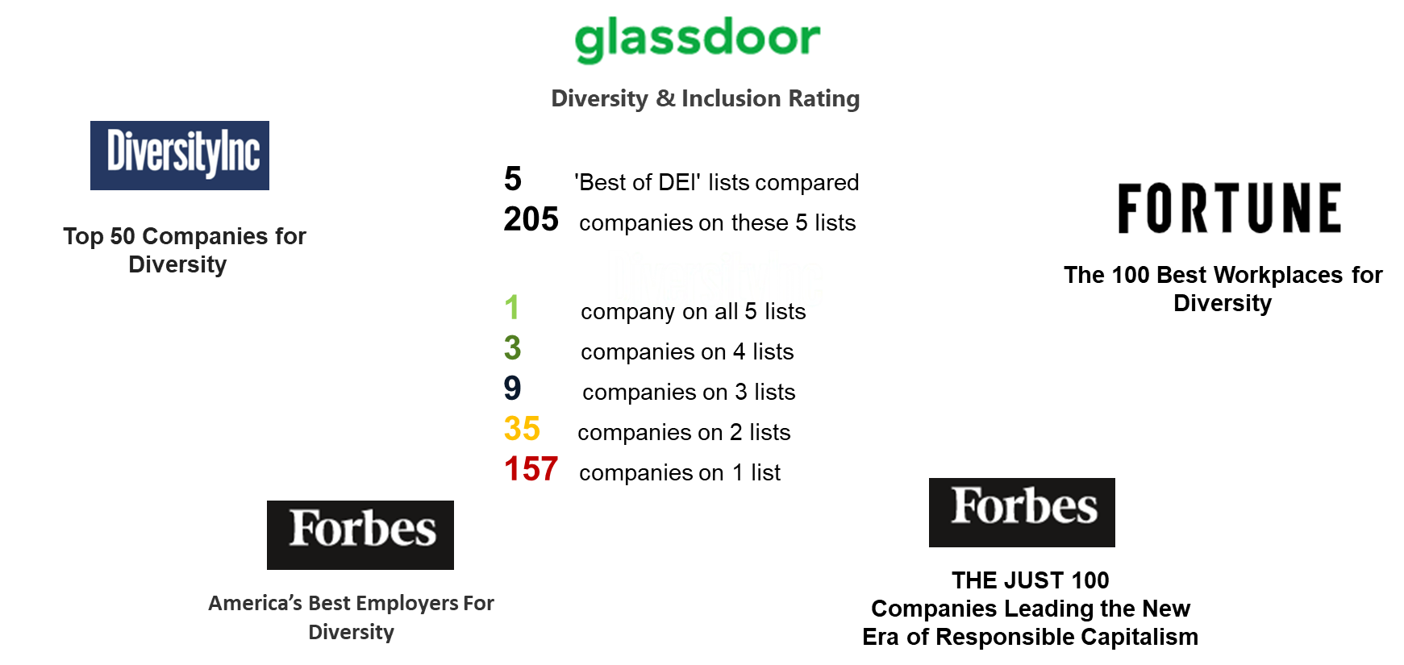
Figure 1: No Consistent Definition of DEI
Think about this for a minute. If we were asked to rank the top 100 financially successful companies, there would be little discussion on how outcomes were calculated, the criteria used, or if results were based on some kind of “pay to play” arrangement.
While we applaud the focus on diversity, these lists may be part of the problem. They each have different criteria, so companies can game the system in some ways. For example, tech companies, always looking for ways to improve their employment brands, have made almost no measurable change in minority representation over the last six years. Facebook has gone from a workforce that is 3% Black to 3.8% in six years. (Apple, Google, Microsoft, and Twitter show similar slow results.)
The problem is not a lack of passion around the issue. Rather these companies look at DEI as a game of numbers: attempting to hire more minority engineers, promote more women or minorities into leadership, and simply push the numbers higher. But do they really believe in inclusion and diversity as part of their business? Do they hold leaders accountable for the results? Is DEI a business strategy or is it buried in HR and focused only on certain talent practices?

Our Ten Major Findings
DEI is an incredibly complex issue and there are a massive number of practices and programs to consider. We looked at top leadership practices, culture and communication approaches, learning and talent strategies, pay and benefits plans, metrics and measures, supporting enablers, DEI and HR structures, skills and capabilities, covering more than eighty distinct practices. We then determined which of these practices most significantly drive seven outcomes - financial performance, customer satisfaction, innovation, workforce engagement and retention, and a sense of belonging. We also checked which practices have the highest impact on these outcomes, which ones were not as impactful, and more.

Finding 1: DEI excellence is spotty.
For some companies, DEI has been a priority for decades. For example, Target has a senior DEI executive and a set of business priorities built around inclusion. The company’s entire mission, “to help all families discover the joy of everyday life,” is inclusive at its core. As Kiera Fernandez, chief diversity and inclusion officer for Target, explained it, “DEI is a business function at Target, not something delegated to HR.”
This is less common than you may imagine. Fewer than 12% of companies recognize senior leaders for inclusion or diversity goals. In fact, 76% of companies have no diversity or inclusion goals at all. Here are some other surprising statitstics:
- Only 12% of companies hold managers responsible for recruiting diverse candidates, and only 11% of recruiters are evaluated based on sourcing from underrepresented groups.
- 75% of companies do not have DEI included in the company’s leadership development or overall L&D curricula. Rather, DEI is treated as a compliance issue.
- Only 32% of companies mandate any form of DEI training for employees and only 34% offer such training to managers.
- Only 22% of companies believe they are recognized by their employees, customers, or suppliers as leaders in DEI.
As you’ll see in our overall maturity model, roughly 80% of companies are just going through the motions and not holding themselves accountable. And the results cleary show these slower-moving companies are not winning awards and they are far less profitable, resilient, and well-regarded than their peers.
Some of the big, well-known companies that surfaced as the highest performers in our survey include: Accenture, ADP, AstraZeneca, Bank of America, Capital One, Dow, Inc., IBM, Indian Oil Corporation, J&J, Land O’ Lakes, The Lego Group, Merck, Siemens, Standard Chartered Bank, Target, T-Mobile, Tetra Pak, Unilever, and VMware.
What is unique about these high-performing companies? We found the following:
- The business itself is defined through inclusion and diversity. Target brings affordable happiness to all families. Cisco brings inclusive collaboration to all communities. MetLife wants to bring financial security to all families. When you frame your business around inclusion, employees and customers recognize the intent.
- They have focused on diversity and inclustion for many years. Companies like Accenture, IBM, and J&J have been focused on this issue for generations. They understand how institutionalized racism and income inequality has become, so they work at this issue over decades.
- These companies live by the culture, not just the metrics. Why have some tech companies had such a tough time? First, they are mostly young companies so their founders and teams have not had time to learn the importance of these issues. Second, they are not truly diverse by nature. Only Microsoft, which has become heavily focused on emerging economies, underdeveloped communities, and disabled workers, truly defines its business around meeting the needs of everyone.
As we explain in the analysis of the five “best of DEI” lists, criteria for external recognition are blurry at best, and downright confusing for the most part. To understand if specific organizational demographics are more conducive to excellence in DEI, we clustered surveyed organizations along geographies, organizational size and industry on our four-level maturity model in DEI (described later).
The insights are fascinating: industry is by far the strongest differentiator in performance, while there are only minor variations by company size or geography. (See Figure 2.)

Figure 2: Lagging and Leading Industry Segments for DEI
Compliance-oriented and risk-averse industry segments – healthcare, manufacturing, energy – are lagging in maturity. Those segments thriving on innovation and consumer orientation – life sciences and pharma, technology and consumer – are ahead.
Why? There are two issues here. First, businesses that thrive on innovation simply cannot compete without diverse perspectives, views, and people. So they are essentially dependent on diversity to grow. Second, manufacturing and production industry segments are more rigid. Companies in this sector may not have the same tolerance for trial-and-error experimentation and listening to diverse employee voices.
Healthcare is an interesting example. Some healthcare leaders acknowledge their DEI programs are weak, yet others have extremely successful programs. Kaiser Permanente, for example, has been a model of culturally competent care and builds equity, inclusion and diversity into all aspects of the business – ranging from the way care is delivered to the many ways the organization contributes to making communities more inclusive, like a massive investment in affordable housing in its Oakland headquarters. When Bernard Tyson, the company’s CEO, unexpectedly passed in November 2019, the company named Greg Adams as his successor. This was one of few times in history that a major organization has appointed a Black male CEO to succeed another.
It's important to remember that Kaiser roots itself in low-cost, inclusive care for all, so its business model is dependent on an inclusive view of its market. We think this is one of the reasons the company performs so well.

Finding 2: Listening to employees is the top driver of excellence.
We correlated 84 practices against a series of outcomes, and one practice was by far the best predictor of excellence: listening to employees and acting on results. In fact, this practice was the strongest predictor of five out of the eight business and workforce outcomes we reviewed.
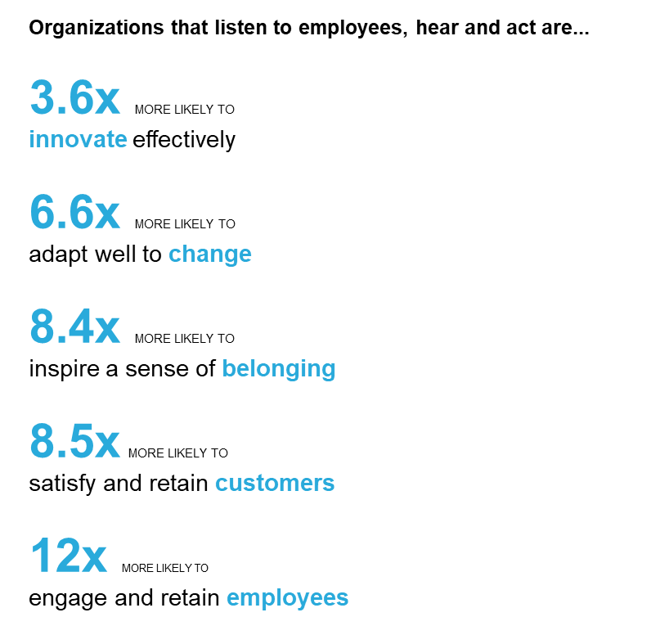
Figure 3: See note in PPT deck
Why is listening so important? Because it switches DEI from a compliance program to one focused on performance and growth. When leaders listen and hear what diverse teams need, they understand the small things that make a difference. When we truly feel empathy, listen, hear, and respond – we are naturally inclusive and diverse as a result.
We need a corporate-wide culture focused on “listening first,” then “hearing what was said,” and then “taking appropriate action.” Or in some cases just making it clear that employees are heard and leaders are committed to working on the issue.
The pandemic has driven this home. It is an unpredictable and sneaky enemy: it changes, moves, and appears unexpectedly. DEI issues can be similarly subtle. We have stories of companies like Verizon, Uber, AstraZeneca, and Sutter Health creating open forums for employees to speak up, express concerns, and give suggestions for the pandemic. When executives let people vent, they create a sense of psychological safety, which in turn creates innnovation, quality, and customer service. When we looked at pandemic response alone, we found that listening was the most valuable practice of all. (For more details read our business resilience study.)
In the case of justice, individuals of all races and genders have been concerned about recent events. When we read about the George Floyd killing, people just wanted to express their feelings. They don’t necessarily want education or expert advice; they want to be heard. Just as any form of counseling starts with listening, we must remember that many of the pains and frustrations of DEI need to be heard. And once we hear what’s on peoples’ minds, we must take action and respond.
Goldman Sachs, for example, held open forums to encourage employees to have conversations about race and discrimination. These sessions – townhalls and community calls -- included messages from senior leadership acknowledging events and condemning acts of racism and provided every employee an opportunity to share insights into their lived experiences.
But listening alone is not enough. It’s important to hear what people say and respond in the best possible way. So companies need to determine how and what to listen for. If people feel the listening is an episodic, reactive practice in response to specific events and not part of a broader strategy to understand and address barriers to DEI, listening sessions can backfire. But when using a comprehensive listening strategy to dig deep into what gets in the way of DEI, the impact can be massive. Goldman Sachs leaders didn’t just listen. Through the forums, leaders learned more about the real barriers and challenges people in the company faced and created action plans around common themes identified. For example, they heard that managers and leaders needed tools and resources in order to serve as allies to employees. In response, leaders provided a guide and toolkit, including an Active Ally Action Plan with a printable list of actionable steps.
At Autodesk, innovation is core to the business strategy. The company has a deeply established culture code that guides the work of everybody in the organization. Inclusion, belonging, and vulnerability are a cornerstone of the culture code. Managers get support and resources to actively listen to their team members in check ins and conversations to identify barriers to an inclusive environment through everyday conversations. Then, they work with the team to address these barriers. This commitment to listening is explicit and part of the management approach at Autodesk.
Cisco, one of the oldest and most respected technology companies in the world, has CEO- and CHRO-led open sessions to listen to employee concerns.
Target quickly organized various listening sessions facilitated by senior leaders. The DEI team provided them with ground rules and facilitation tips, with the result that thousands of people spoke their minds in these sessions. Then, the team aggregated insights to determine what next steps to take.
Sutter Health cancelled one of its four weekly leadership team meetings to allow managers time to connect and listen to their teams.
For Microsoft, listening is an integral part of the growth mindset and the cultural transformation Satya Nadella has facilitated to turn the company around. “We want our leaders to come into the room with the intention to get it right, not to be right, and therefore to listen and learn from others,” said Kate Johnson, Microsoft U.S. president. Courageous leaders display empathy and listen to different view points, approaches and needs.
“Listening is a power skill. It is not enough to hear people, we must ensure people feel heard," said Ray Narine, deputy director of diversity for Consumer Reports.
Listening has to happen on various levels: the individual level, the team level and the organizational level. How can organizations listen all the time and take action on the results?

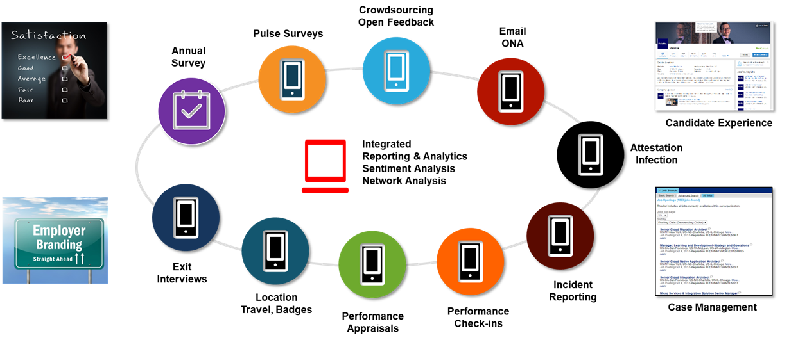
Figure 4: A Complete Listening Architecture
A study by Deloitte showed that high-performing organizations use an average of seven listening channels, compared to just three used by low-performing companies. Annual employee surveys – using tools like Medallia, Qualtrics, Glint and many others - are a mainstay of insights, as are HCM and ATS systems where demographic data are housed. Companies can get a much richer picture of what is happening by adding pulse surveys with topical questions targeted at specific concerns, crowdsourcing open feedback with tools like Waggl, analyzing employee sentiment in performance check ins and evaluations, scouting internal and external social media, and evaluating trends in claims and tickets All of these can be part of a comprehensive listening architecture (see Figure 4).
For example, a large U.S. healthcare company identified through its employee survey that while overall feelings of inclusion in the organization were high, the scores for the ability to speak up about mistakes or issues were low, indicating issues in psychological safety. As leaders dove deeper into the data, the issues became even more striking. Women and people of color felt less encouraged to speak up, especially when looking at intersectionality. For example, the data showed dramatic differences in levels of comfort felt by Black women in nurse practitioner roles, compared to white men in leadership positions.
Once the problem was identified, focus groups and pulse surveys provided additional details and stories around the issues. Connections with patient satisfaction and outcomes were established analytically and backed by real-life stories of nurses who felt they could have changed patient outcomes if they were free to speak up about physician practices. As the company assembled a cross-functional program to increase psychological safety, that team crowdsourced ideas from employees and listening not only to learn about problems but also to identify solutions.
While this practice is not in itself something commonly associated with DEI work, it is much more impactful than any of the more traditional practices to move the needle on business outcomes and create a more inclusive and equitable environment.

Finding 3: HR skills are low and must be improved – in every HR role.
As part of our work to be the world’s home for HR, we are providing to Josh Bersn Academy members a capability assessment based on an in-depth analysis of 94 detailed capabilities in 20 categories. HR professionals can assess their capabilities, determine benchmark gaps, and then obtain direct development plans to grow.
To date more than 3.500 HR professionals have completed this assessment. Surprisingly, among the 20 broad categories, the one with the lowest proficiency is DEI (see Figure 5). A mere 3 percent of respondents claim deep expertise in this area, while about four in five HR professionals assess themselves as beginners in DEI.

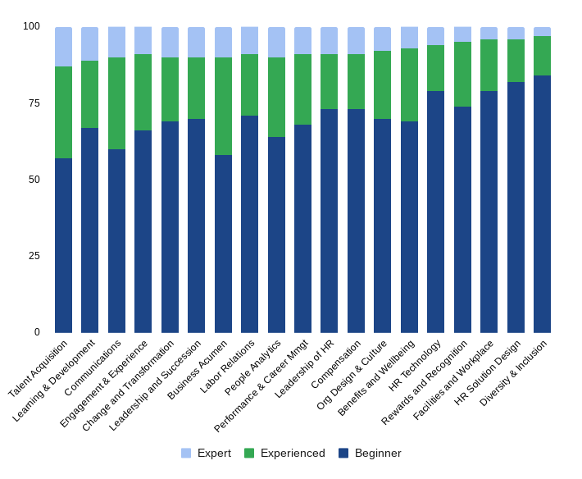
Figure 5: HR’s DEI Capabilities Rank Lowest of 20 Areas Studied
In some ways, this is not a surprise. Given the complexity of DEI, many HR professionals feel they “don’t know what they don’t know.” As a result, DEI programs are often led by a small number of DEI specialists who have spent years or decades working in the area.
As one can imagine, a small set of specialists cannot possibly enable all HR professionals to help move the needle. So it is critical to build awareness, broad capabilities, and specific action plans for all HR roles.
The research clearly proved this result. Organizations that invest in HR capabilities in DEI are much more likely to have outstanding results (see Figure 6).

Figure 6: Rework? See note.
When we looked at the various outcomes from this study, HR capabilities were the most predictive of financial performance. Organizations with strong DEI consulting skills in HR are 220 percent more likely to have strong financial performance. Why? We believe this consultative approach creates efficiency. When HR business partners, recruiters, and organizational design staff understand and drive inclusive practices with confidence, their companies have a stronger employment brand, managers understand have clearer direction, and employee retention, teamwork, and productivity improve.
These capabilities also positively impact leadership. When HR teams can competently advise on topics such as recruitment bias, equitable performance management, inclusive team leadership, and pay equity, the leadership team feels more confident. Managers and supervisors don’t feel as if they have to become DEI experts, and results are felt throughout the enterprise.
One of the senior HR leaders we work with is in the construction industry, where most of the staff are blue collar men. The company, a spinoff of Hertz, is known as one of the most diverse and inclusive businesses in their industry. He told us, “My job is not to teach every manager to be a DEI expert. I want them to learn how to be a fair and inclusive leader, and our job is to sensitize them to the topic. I expect our HR professionals to do the heavy lifting – coaching, supporting, and correcting them along the way.”
We also know that strong HR business partner expertise leads to innovation. Companies with excellent HRBP skills in DEI are three times more likely to be innovation leaders. Why? When different ideas, mindsets, and backgrounds come together and can work on customer problems, everybody wins. Perhaps most strikingly, when DEI is embedded in every HR program – not as a stand-alone program or initiative -- organizations are 8.2 times more likely to engage and retain customers. This is because diverse employee teams can naturally better serve diverse customers.
Siemens, for example, uses design thinking in all different areas of HR – recruiting, L&D, leadership development, talent management, compensation, total rewards – to determine how to embed DEI into existing programs. Using input from employees as a starting point, the team continuously identifies pain points and revamps programs such as those for career development with inclusion and equity in mind.
Where do these DEI capabilities matter? For an HR business partner supporting the marketing function, it can mean helping to test a marketing program with an LGTBQ resource group to understand how it would resonate in that community. An HR tech professional may look at intersectionality or diversity measures to understand time to hire or retention metrics in recruiting. A team charged with designing a new onboarding or performance management program would reach out to representative employee groups and involve them in them in design review, piloting, and testing. When armed with the skills to ask the right questions and collect meaningful data and feedback, HR can have an enormous impact on business and DEI outcomes.

Finding 4. DEI must permeate the talent supply chain – from hire, to promotion, to growth.
The knee-jerk reaction to diversity problems is usually to start on hiring. Let’s figure out how to bring more diverse talent into the organization! This leads to a number of interesting questions. Where do we find candidates with different backgrounds, abilities, ethnicities, races, genders? How do we assess candidates fairly, so educational pedigrees or race is not included? Should we anonymize resumes? Create recruiting pools or diversity committes? Or even set quotas?
The research and conversations show that a hiring-only approach simply does not solve diversity issues. Minority candidates quickly leave an organization if they feel excluded or see no diverse role models in leadership and management.
What our research shows is that inclusive design must be built into performance evaluations, rewards and pay, opportunities to grow and develop, and the entire succession and career process. Consider the stark differerences between excellent organizations and low performers (see figure 7).
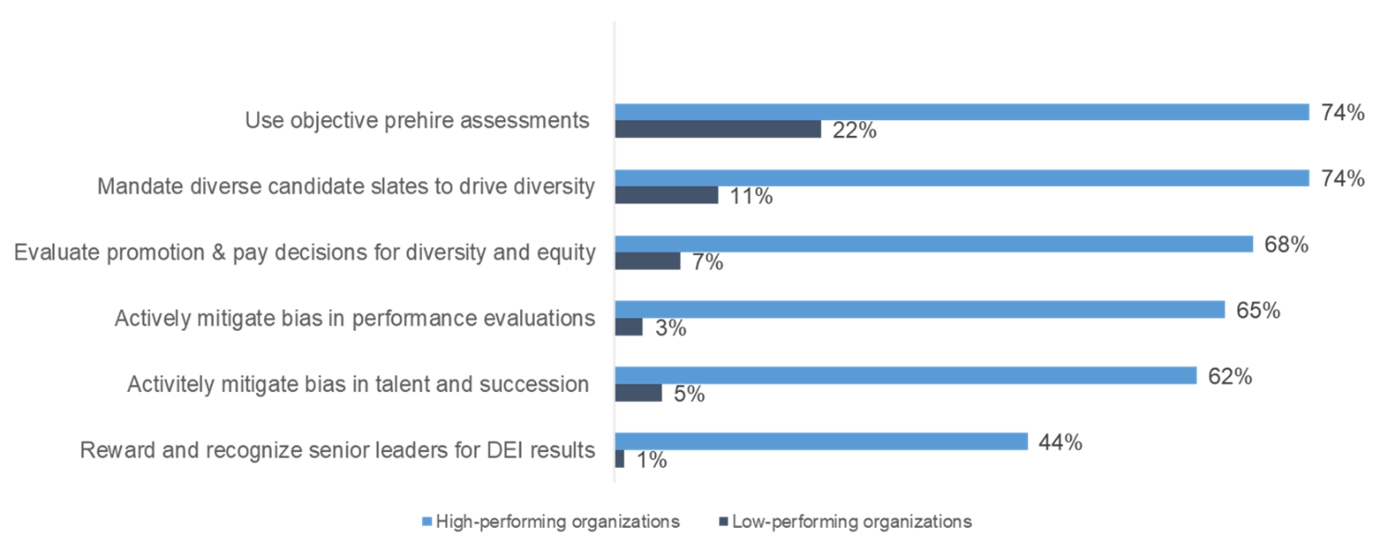
Figure 7: DEI Practices Implemented in High- and Low-Performing
How do you do this? The core of any solution is to mitigate bias, and to do that, we have to accept that bias exists. If you haven’t taken Harvard’s Implicit Association Test, do it. You might be surprised to learn about your own biases. Bias is part of the human condition. So how do we overcome biases?
“You can’t drive bias out of the person, you have to drive it out of the process.” CHRO of a large consumer product company.
Rather than just providing bias training to raise awareness, high-performing companies use structured interviews, diverse candidate slates, and work sample tests to mitigate bias in hiring. Goldman Sachs uses the “rule of two” drive diversity into hiring. The goal is to have two diverse and qualified candidates interview for each open role wherever possible, and hiring managers are accountable for interviewing a diverse slate of candidates.
Deutsche Telekom uses diversity scouts to drive bias out of hiring decisions. Chevron uses diversity committees to review all pay, promotion,w and career decisions and take the power out of the hands of a single manager.
New tools such as those based on video can also introduce bias. Quantas moved away from video interviews for volume hires because of inherent bias. Videos can introduce bias for race, gender, or age, as well as factors such as backgrounds and attire. Instead, Quantas now uses a pre-screening tool by Predictive Hire that walks candidates through a number of questions via text message and ranks all candidates – often up to 1,000 for a single position – based on their fit for the job. Candidates love this approach because they found the video interviews awkward and impersonal. Hiring manager are happy too because they get better candidates much faster.
After its high-profile discrimination lawsuit, Coca Cola reviewed all performance evaluations, promotion and pay decisions and talent reviews for bias before the decisions were made, and addressed them proactively, significantly increasing opportunities for Black employees.
Interview guidelines are also critical. In California, a law prohibits recruiters from asking candidates for current salary information to prevent further aggravating existing gender pay gaps. In the U.K., it is now mandatory to disclose gender pay gaps; some companies such as Salesforce and Adobe are already doing this in other parts of the world.
Technology can redact resumes to remove words indicating gender, ethnicity or race to mitigate bias during resume reviews – but only 8% of surveyed organizations leverage this kind of technology. Other technologies can highlight words in performance reviews that indicate bias. For example, a study showed that women are much more likely to receive feedback based on their personalities rather than their accomplishments.
While we can never be truly unbiased, we can mitigate biases in our talent decisions using bias disruptors and creating processes that create a more equitable talent experience.
This integration of DEI with all talent practices is critical for the success of DEI, and some organizations are making structural changes to their DEI teams to foster this approach. For example, at Consumer Reports, CHRO Rafael Perez is also the head of DEI because the company acknowledges that all people practices need to be reviewed and modified with a lens to DEI. At Hilton, DeShaun Wise Porter leads diversity and inclusion and is also accountable for employee engagement. Herc Rental’s Mark Arell is accountable for talent management, organizational development and DEI because the company sees DEI as a culture and talent priority. Tetra Pak’s Gabriele Youd heads up the company’s future of work which also includes DEI because only through diversity can the company create the innovation necessary for its future. Of course, organizational structure is not the only way to drive this integration. Other companies like Target or Siemens drive this integration through collaboration and shared goals, still accomplishing the same outcomes.

Finding 5. Diversity training has limited value, but C-suite commitment can make a big difference.
Most DEI leaders are convinced that educating leaders and employees will move the needle. Our research proves otherwise.
Still, such training is common: 32% of organizations make sexual harrassment and diversity training mandatory for employees, managers, and executives; about one in four companies have programs on unconscious bias. Supporting DEI training is a massive industry of courses, books, teachers, and podcasts on the subject.
But even use of DEI training is inconsistent. For example, 57% of energy-related companies require all employees to attend DEI training, as compared to 22% of manufacturers and 15% of healthcare organizations. Why is it so inconsistent? Because companies don’t really believe it will do much. When we asked leaders why they don’t do a lot of training, they use words like “unauthentic,” or “misaligned” or “we’re still in our infancy.” Many told us such programs are “superficial” or “inconsistent,” and our data bears this out.
Let’s face it, training is used as the first line of defense. It lets the company avoid some lawsuits and it’s easy to do. You can buy some courseware, tell everyone it’s mandatory, and just roll it out.
Many studies have shown that training can raise awareness, but its impact on behavior change is limited. The CHRO of a large global manufacturing company headquartered in Japan told us that its diversity training in Japan, which focused on increasing opportunities for women in the workplace, received negative responses from both men and women because they saw the program as furthering division among the workforce.
In our analysis, DEI training rated at the bottom of the list for impact on business and workforce outcomes and sometimes even showed a negative correlation. One-off, disconnected training doesn’t make a difference, but active C-suite commitment to DEI does. (See Figure 8.)
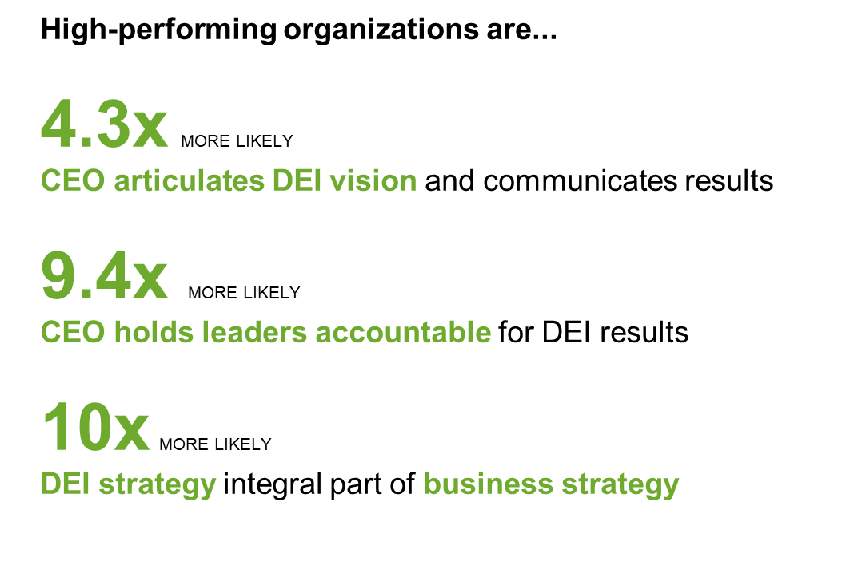
Figure 8: See note about reworking.
Why does this make sense? Because DEI is not a training problem – it’s a strategy and culture problem. Think about the social issues currently at play. In the last two years, the four biggest issues have been health and wellbeing, income inequality and standard of living, global climate change, and racial injustice. These four issues are connected: global climate issues have created changes in animal populations and severe weather; a lack of education and job mobility caused by years of racial injustice has created income inequality; and feelings of powerlessness and political unrest have raised issues of equitable justice. CEOs can’t expect their organizations to cope with these issues through training; they have to set a complete business agenda that includes diversity, equity and inclusion.
From a business standpoint, our research points out that the most inclusive businesses are those that endure. Pharmaceutical, technology, telecommunications, and consumer goods companies sell to a wide range of consumers; they honor a diverse customer base as well as a diverse supply chain; they find that a diverse workforce helps them create the right solutions for these customers.
For Consumer Reports, the breakthrough happened when DEI results were embedded in the quarterly business updates to all employees along with financial and customer results. Cisco reimagined its mission statement to be squarely centered around inclusion: “Power and an inclusive future for all.” Nestle sees diversity and inclusion as a business differentiator that can enable better product development for its diverse customer base. Target knows that making anybody – regardless of ethnicity, race, background, sexual orientation, religion, age or any other demographic - welcome is critical to its success.
An inclusive guest experience is dependent on an inclusive employee experience, and so creating that experience for employees is critically important to business success. At Hilton, CEO Christopher Nassetta sees guest and employee experience as intrinsically connected. Microsoft’s purpose is to empower every person and organization on the planet to achieve more, and CEO Satya Nadella explains in detail why a culture of inclusion is indispensible for the company’s business success. A large telecommunication company factored equity into decisions about the placement of cellular towers because land owners get significant compensation; finding lower-income areas in which to build towers can help to distribute wealth.
All of these examples have one thing in common: a shared purpose that people buy into, inspires them, and brings a sense of belonging.
CEOs usually talk about financial success, customer growth and business strategy with their employees, shareholders and other stakeholders. It’s easy to see if they are bought into DEI strategies and goals within and outside of the organization. Do they talk about these topics as frequently as about other business results? Do they take responsibility for progress and failures in these areas? Do they share their own stories? If the answer is “no” to questions such as these, the commitment might be more lip service than genuine, making progress in DEI hard to sustain.
Training is what we call a “supporting act.” If you focus on the five essentials, then training can complement your solution.

Finding 6. Metrics and goals are mandatory for success.
“DEI work needs to be managed as a business function, not an HR program,” said Kiera Fernandez, chief diversity officer,Target
You wouldn’t run your business strategy, your finance strategy, or your marketing strategy without measurements. But DEI metrics are challenging for several reasons:
- Lack of HR skills: About four in five HR people are inexperienced in putting DEI metrics together, according to our capability assessment. Who should run these metrics and discuss them with business leaders? As we identified earlier, HR skills need to be improved across the board in all areas of DEI, including metrics.
- Lack of focus on inclusion: Traditional metrics focus primarily on representation of gender, ethnicity and race – all easy to track and sometimes legally required (such as EEOC/AAP reporting). However, these metrics only focus on diversity representation, neglecting inclusion. What good does it do to recruit diverse candidates, only to have them leave the organization or expect them to assimilate?
- Lack of context: Frequently, these measures are often not put into context on what success looks like outside the company. Without this outside-in approach, it’s hard to determine where the industry is going and what benchmarks might be feasible. Without context, companies often set unrealistic goals – either too ambitious (as we see in many tech companies who consistently miss the boat on their goals) or not challenging enough to bring change.
- Lack of transparency: Employees expect to be informed about the company’s financial progress, customer success and other operational success measures. If DEI is part of the business strategy, then metrics and progress need to be shared with the workforce, too. According to our study, fewer than one in three organizations do this well.
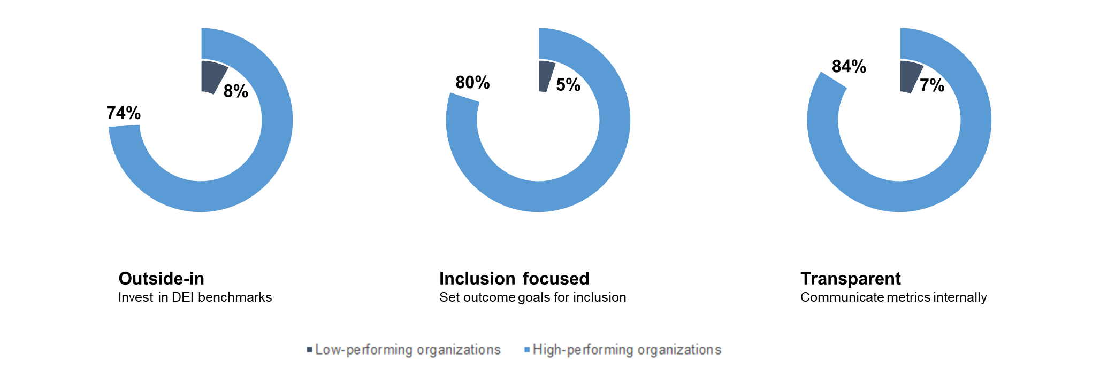
Figure 9: DEI metrics practices of high- and low-performing organizations
Our study shows that three practices around metrics drive success (see Figure 9). Excellent organizations use these practices for DEI metrics:
- An outside-in orientation: Rather than merely comparing internally, the most successful companies invest in external benchmarking and comparison – within and outside their industry segment. Target, Accenture, Kaiser Permanente, Tetra Pak, Siemens and many others have dedicated analytical experts who collaborate with various groups outside the organization to identify metrics and measurements that drive results, helping them apply a leading practices mindset to DEI work.
- Focus on inclusion and belonging: In addition to the standard representation metrics, excellent organizations add outcome goals for inclusion to the metrics mix. An inclusion index, derived from the employee survey, is one way to do this. Many companies have aspirations to put an inclusion index on their DEI metrics dashboards, and companies like Culture Amp, Glint and Medallia can help define such an index.
- Transparency: Tech companies like Google, Facebook, LinkedIn and Twitter all have been very transparent to external audiences about often over-ambitious DEI goals and touting initiatives for creating equity for women and people of color on their leadership teams. While well-intended, these goals are often not met, and they leave out an important stakeholder: the workforce which lives and breathes the DEI results (or the lack thereof). Rather than seeing DEI targets as a publicity opportunity, companies should focus on keeping their internal audiences appraised on progress. That includes employees, managers and leaders. Consumer Reports announces DEI goals and progress together with financial targets and customer results. Hilton is also increasing DEI transparency in 2021.
Measurements are key. You can’t create a strategy without defining how you’ll measure success. The right measurements will tell you where you are, where you need to go and how to get there.

Finding 7. The business must be accountable for DEI.
Who is “on the hook” for diversity, equity and inclusion? Is it the chief diversity officer? The head of HR? The CEO?
Done right, DEI accountability resides in every business unit, in every function, on every team. One person or one team can’t alone be accountable for success. If you run DEI like a business function, this becomes glaringly obvious. Would you hold the CFO of a company accountable for the financial success of the company? Of course not. CFOs are responsible for supporting each leader to hit financial targets, but the accountability lies squarely with each business function.
The same holds true for DEI. When we checked what practices most drive external recognition for DEI, we found that distributed accountability is essential (see Figure 10).
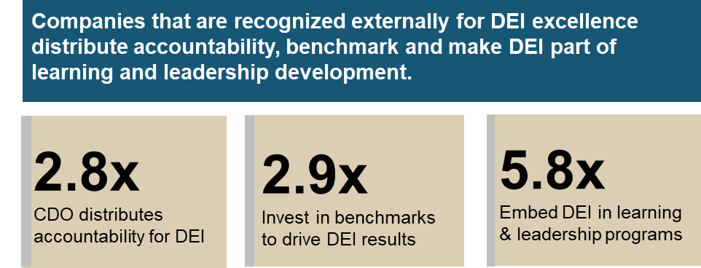
Figure 10: See note.
According to our study, accountability is really the one topic that moves companies into the highest level of maturity in DEI. Without accountability at all levels and throughout the organization, progress in DEI is not sustainable. Coca-Cola is a cautionary tale. The company made amazing progress on hiring and promoting Black executives from 2000 to 2010, but progress almost evaporated because focus was lost. DEI progress was dependent on personalities of leaders (some of whom left the company), rather than being embedded in the organization.
But how do you create that accountability? Our research shows that only 12% of leaders are rewarded and recognized for accomplishing DEI results. Before creating accountability, people need to have the necessary skills and capabilities to execute on the work. So it’s not surprising organizations recognized as leaders in DEI are 5.8 times more likely to embed DEI in all learning and leadership programs.
Auditing existing development programs with a DEI lens is much harder than building stand-alone training programs, but the effort pays off. Siemens reviewed its existing programs to integrate a DEI focus. Kaiser Permanente, a company focused on psychological safety and creating a speak-up culture, updated behavioral expectations to incorporate that angle. Herc Rentals wants to change behaviors first, starting with mandating diverse candidate slates, actively recruiting from sources that help bring the company closer to diversity goals, and increasing the representation of women in leadership. Tetra Pak drives accountability with regional DEI panels to set strategies, defining goals and oversee progress. Consumer Reports knows that accountability starts with capability, and so the company first focused on developing manager capabilities to drive DEI forward and then established accountability processes with metrics and goals. DuPont includes diversity, equity and inclusion in the quarterly ops review that every business leader needs to complete and is accountable for. For Microsoft, it’s all tied to a growth mindset – leaders need to get it right not be right, and listen and learn from different perspectives. “Courageous leaders take accountability for developing the people and processes in their care,” said Kate Johnson, president of Microsoft U.S.
All of these approaches are unique to the company environment and culture, and they foster accountability not just at the center but in each business unit, functional area and location. When DEI is core to the business itself (as opposed to a philanthropic effort), then business leaders will be accountable for building an inclusive culture and elevating diversity, just like they are accountable for financial performance and customer success.

Finding 8. DEI leadership and programs don’t matter much; executive focus drives results.
There are many theories about what practices work to make a lasting impact on DEI in organizations. So leaders tend to implement a variety of programs: bias training, employee resource groups, women in leadership programs, mentoring, and more. Does all this investment pay off?
Our research shows that the answer is “no.” Without senior business leader commitment, a heavy investment in the DEI programs has limited impact. (See Figure 11.)
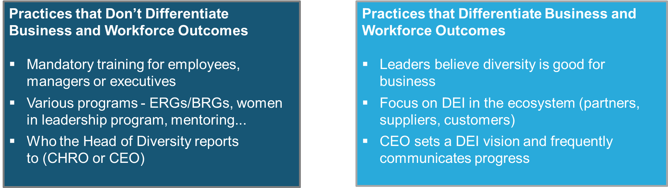
Figure 11: Practices That Do and Do Not Differentiate Outcomes
We looked at many correlations. Should the DEI executive report to a line leader? Should there be DEI-focused business partners? What levels of investment are made in DEI? In all cases, these various actions had little impact without executive ownership.
If you’re looking at spending more money on DEI, you may be better off promoting an internal leader into the job and spending time developing an inclusive business strategy and set of business objectives, rather than hiring a DEI expert and then developing and launching a set of new programs. Remember, the problem we’re solving is to create a sense of equity and fairness in the company. These are management issues first, training and HR issues second.
Here’s the evidence to support our finding:
- When business leaders believe that diversity is good for business, organizations are 2.9 times more like to excel in innovation. They create diverse teams, foster a speak-up culture, and facilitate innovation from various viewpoints and perspectives. For example, Telstra is highlighting role models and sharing stories of women succeeding in traditionally male roles. A large biotech company uses a sponsorship program to support its rising minority leaders with senior leadership support. An added benefit of this program is that the mostly White senior leaders learned more about the capabilities and performance of the people they are sponsoring.
- Focusing on DEI in the company ecosystem – partners, suppliers and customers – is linked with twice the likelihood to excel financially and 4.6 times the likelihood to satisfy and retain customers. This is because creating products and services for diverse customers is recognized both financially and with customer loyalty. Such focus requires that senior leaders in all areas are sensitive to all aspects of DEI. Hilton’s leaders correlate customer satisfaction and retention to the creation of a welcoming guest experience for everybody. P&G creates packaging for visually impaired customers, and Kaiser Permanente is deeply committed to culturally competent care and acknowleges different care needs based on on ethnicity, gender, race, and age.
- When the CEO sets the strategy and frequently communicates DEI progress, the company is 6.3 times more likely to to have a diverse leadership team and also to be a leader in its industry segment. Target CEO Brian Cornell refers to the importance of diversity, equity and inclusion in all communications and townhalls. Accenture CEO Julie Sweet believes that a diverse workforce and equality for all drives innovation and customer success. M&T Bank’s Rene Jones (one of the four Black CEOs in Fortune 500 companies) aims to build deeper relationships with communities to rebuild the social contracts that bind American cities together. Whether the chief diversity officer reports directly to the CEO, to the CHRO, or another senior leader doesn’t make a difference. Whatever the reporting structure, the DEI leader must work with the CEO to set the company-wide strategy, just as the CFO works with the CEO on the company’s financial strategy.
“The message has to come from the top, and people will march to the tune. What matters is the clarity of the message and the leader walking the talk,” said Neville Isdell, former CEO of Coca Cola, in an interview with the Wall Street Journal.

Finding 9. DEI excellence absolutely does drive superior business performance.
As we said earlier, the business case for DEI has been proven over and over. It’s well acknowledged that diverse teams demonstrate higher levels of innovation, financial success, and customer satisfaction. But what are the practices that deliver these results?
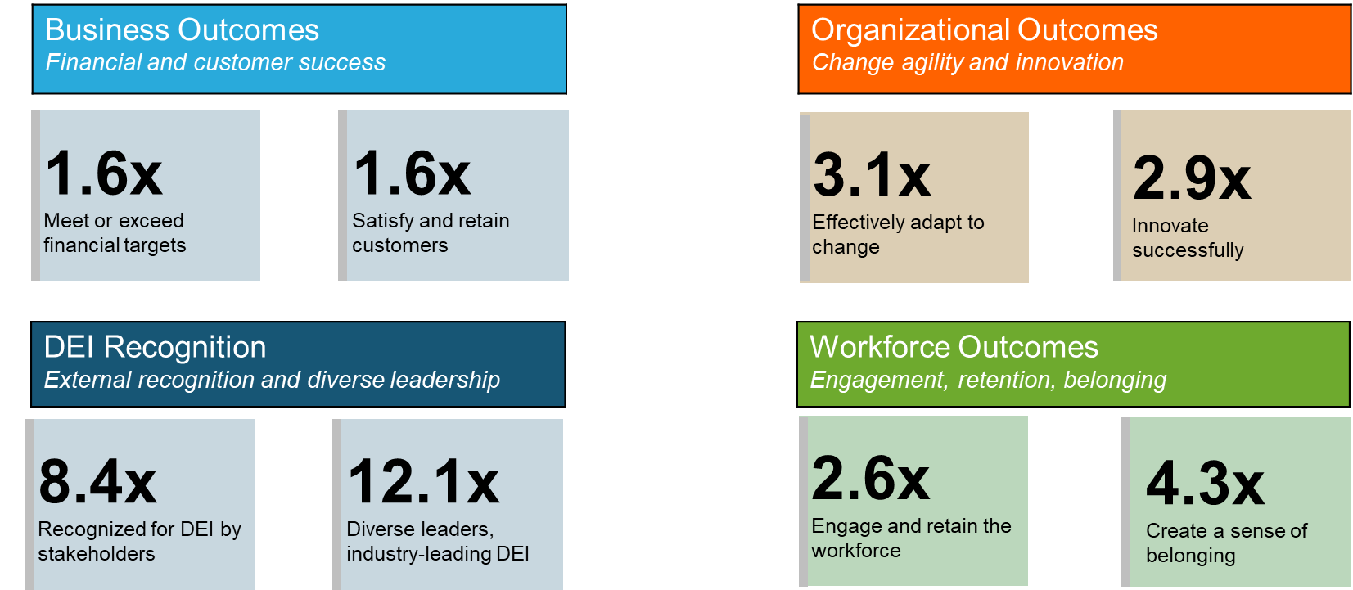
Figure 12: See note.
Our study found that organizations focusing on the right DEI practices have superior business performance and results, and they also create a more inclusive environment with higher employee engagement and recognition for DEI (see Figure 12). These 15 practices are described in detail later in this report.
In essence, organizations thrive when leaders listen, hear and act to identify barriers to DEI; build strong HR capabilities in DEI; have active C-level drive behind the DEI strategy; use the right metrics and measurements; and hold themselves accountable for DEI outcomes.
None of these practices are quick fixes. They are systemic cultural shifts that will take years to master and can never be stopped. Compliance can start the process but will not sustain it. The Coca Cola story – where progress deteriorated after ten years of progress following a high prifile lawsuit – is an example of the need for sustained attention.
Or take the National Football League case in 2002, when two African American head coaches (of just five in 80 years of history) were fired within two weeks, leaving just one African American head coach in a league in which 67 percent of the players were African American. A study in the performance of head coaches revealed that African American coaches outperformed White coaches but were consistently passed over for head coaching jobs. The study’s findings resulted in the Rooney Rule (after former Pittsburgh Steelers owner Dan Rooney) which requires NFL teams to interview at least one candidate of color before hiring a new head coach. In a single season, the rule helped increase the number of coaches of color from two to eight. (However, it’s important to note the Rooney Rule’s record is spotty at best. For example, in 2019, seven of eight open head coach openings were filled by White coaches.)
If we think about DEI as a business function, not as an initiative, this shouldn’t be surprising. You wouldn’t stop marketing once you hit your marketing goals, or stop your selling when you meet your numbers. The right practices put together in a cohesive strategy and run like a business function make a big difference of the success of the company, creating sustainable competitive advantage.

Finding 10. Inclusion is the goal; diversity is the result.
Diversity and inclusion are often used interchangeably, but they are actually quite different. A company can have high diversity among employees (various backgrounds, ethnicities, races, genders, abilities, ages, sexual orientations) but limited inclusion. For instance, employees in a minority may feel as if they don’t belong, that their perspectives are not valued, or that they can’t be their true selves at work. Conversely, a company with a very homogenous workforce can foster high inclusion. In either these situations, you will not likely get the variety in voices and perspectives that yield the innovation, high customer satisfaction, and the resulting financial performance seen by high-performing companies.
Our study shows that starting with diversity is putting the cart before the horse. The practices that create the best financial, customer and organizational outcomes are inclusion practices that, in turn, make diversity sustainable. Many companies monitor recruitment of diverse candidates but neglect to also determine if these new hires feel included and have a sense of belonging.
Among the most impactful practices for creating a diverse leadership team is measuring inclusion outcome goals, for example, through an inclusion index. Companies that do this well are 6.2 times more likely to have highly diverse leaders. You might think that to increase leadership diversity, you need to recruit more diverse leaders, increase the diversity of the leadership pipeline, and support the promotion of diverse employees. But these practices in themselves don’t create sustainable diversity.
So if belonging and inclusion are so important, how do you create these feelings? Our study shows that HR consulting, support for authenticity, and listening play the biggest roles (see Figure 13).
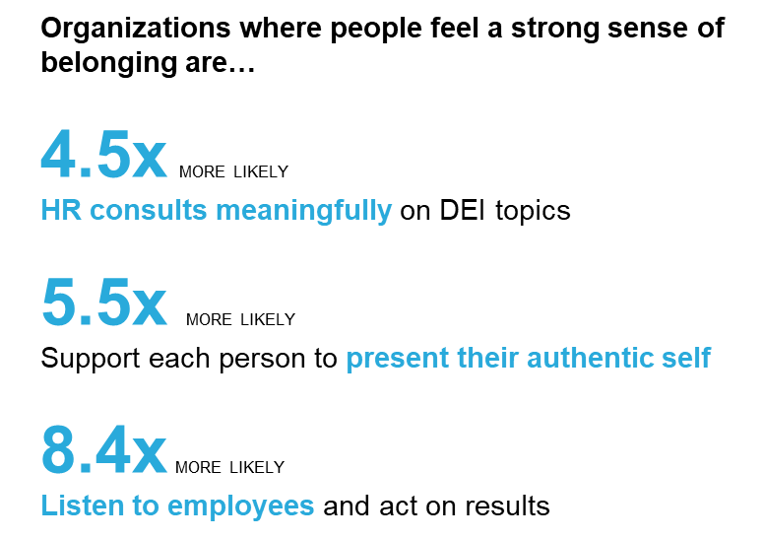
Figure 13: See note.
Each of these practices impact different areas. HR consultation on DEI topics often addresses manager-level issues by supporting managers in creating more inclusive work environments. Authenticity points to a speak-up culture of psychological safety, and listening requires respecting the opinions of all, collaborating on solutions, and giving people agency and power.
A sense of belonging also requires an underlying shared purpose to which everyone can subscribe. “When team members have a strong sense of shared purpose and the feeling that they ‘belong,’ creating inclusive work environments come much easier,” said Marc Arell of Herc Rentals. And an inclusive work environment then unlocks the value of the diversity that everybody works so hard to create by bringing in candidates from different backgrounds, creating diverse teams, and supporting all people to grow and develop.

The Five Essentials and Fifteen Practices that Matter Most
What we found in this study was astonishing. Out of more the 84 practices studied, we found five essential strategies and fifteen ancillary practices to have the greatest impact on business, organizational and workforce outcomes. (See Figure 14.)
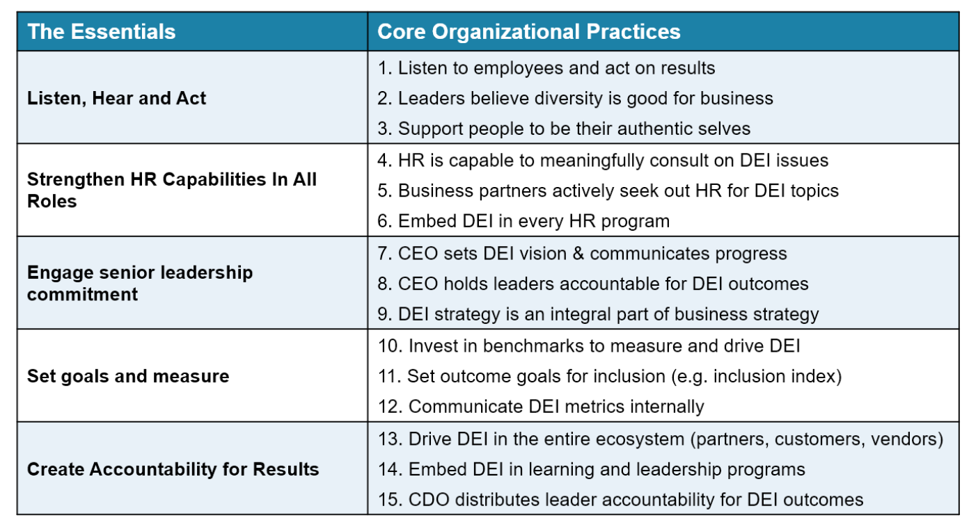
Figure 14: The Factors and Practices for DEI
You’ll note that most of these are not typical DEI practices. They revolve around listening, HR capabilities, leadership commitment, and accountability.
These core practices build the foundation of a DEI strategy that is specific and unique to the organization, the needs of the workforce, and the business environment. These practices create a systemic change that is sustainable and cultural.
- Listen and act. When leaders listen frequently to employees, hear what they say about barriers to DEI, and then act on these insights, they can collaborate to create an inclusive environment. Ongoing listening is not an easy thing to do, and it needs to be supported by rigorous evaluations and action taking mechanisms. Leaders need to create an environment in which each person can “share their lived experiences,” as Target Chief Diversity Officer Kiera Fernandez put it. “When we talk about DEI, I often ask business leaders if they believe that diversity is good for business. It gives me insight into the culture on their team,” said Mark Arell, vice president of talent and organizational development for Herc Rentals. Such beliefs help people feel comfortable being authentic, speaking their truths, and share even sharing uncomfortable perceptions.
- HR has a key role to play. HR should not be viewed as the enforcer of rigid rules or mandated quotas, but as a consultant to the business, helping leaders address key DEI issues. Building HR capabilities to do this well has to be an organizational priority. When leaders recognize that HR partners have the ability to ask the right questions and add value to DEI discussions, they will give HR the “seat at the table” to define strategy and tactices for DEI. “You need to review every HR program with a lens to DEI. Your diversity recruitment strategy is your recruitment strategy; your inclusive leadership program is your leadership program,” explained Consumer Report’s Rafael Perez.
- Leadership engagement is critical, as with any business function. Without it, any progress with be fleeting and short-lived. People see through lip service and demand honest leadership commitment. ‘Our CEO is personally driving our DEI strategy, with our support,” said Kiera Fernandez. Holding the leadership team accountable for DEI outcomes is critical. Deloitte Consulting’s CEO Dan Helfrich starts his leadership meetings with two questions: “How can we make this team more diverse?” and “How can we make this team more inclusive?” A DEI strategy that is outside of the business strategy will always result in a set of programs, initiatives and tactics that are seen as discretionary. The most successful companies embed DEI as a business imperative into the mission, vision and strategy itself.
- Metrics and measurements help set goals, create plans, and prioritize work. Looking outside of the company boundaries, it’s important to benchmark with other companies to define the right goals. “To drive real change in the environment, we need to work together with others in the industry, sharing our goals and leading progress in our communities,” said the CHRO of a large biotech company who is planning to bring together a consortium to create more inclusive environments in their industry segment. Metrics that matter most focus on inclusion and are communicated broadly, keeping everybody in the loop on progress made. “We are going to increase the transparency of results in 2021 to update all team members on progress,” said DeShaun Wise Porter, the head of diversity at Hilton.
- Accountability needs to happen at all levels – within and outside the organization. No one person or group can create significant DEI results. Just like with any other business imperative, progress and outcomes need to be shared to make a meaningful impact. This means creating an ecosystem for DEI, including supplier diversity programs. Walmart, for example, spent $11.7 billion with diverse suppliers in 2019, up from just $2M in 1994. Embedding DEI in all learning and leadership programs means creating the foundation for accountability. “You can only create accountability once people know what they are accountable for, and have the skills needed to execute. So you need to educate first, and then you can create accountability,” said Ray Narine, head of talent development and deputy diversity officer at Consumer Reports.

Other programs matter, but only if the essentials are in place
With 84 different practices to study, we found many other important practices that clearly matter but that don’t distinguish outcomes the same way. While these practices can be valuable in supporting the core practices, they don’t have much impact when implemented alone. (See Figure 15.)
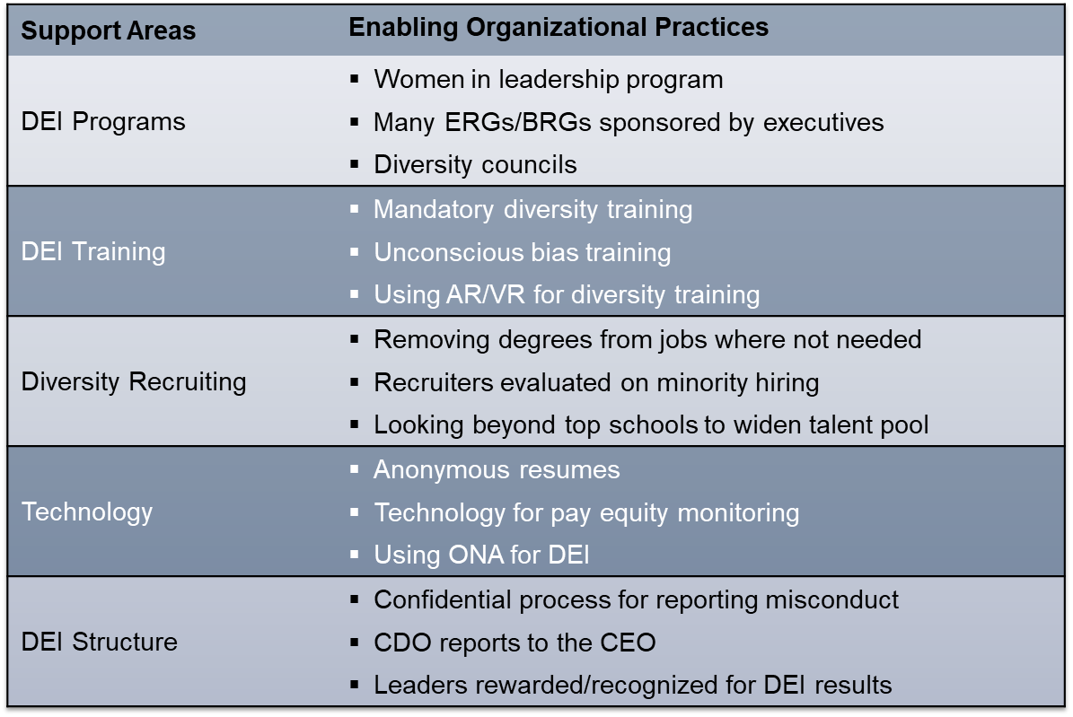
Figure 15: The Least Impactful Organizational DEI Practices
- DEI programs have been a staple of most DEI approaches for a long time. Women in leadership programs, ERGs/BRGs, or diversity councils are often the go-tos when starting out on the DEI journey. But without a broader strategy and proper framing, they can backfire and create more division than unity. Siemens is putting its women in leadership programs into the broader context of what diversity and inclusion really means for the business.
- DEI training: Much has been written and researched about DEI training. We found that even using when using advanced approaches in DEI training, such as augmented or virtual reality, the programs have only marginal impact when used without an overarching strategy. Target has deployed immersive experiential DEI training in support of its comprehensive DEI strategy with the goal of helping educate managers and indivuals about biases and creating cultural competence.
- Diversity recruiting might come as a surprise on the list of least impactful practices. These practices certainly can help bring more diverse talent into the organization, but without an inclusive environment in which people can be their authentic selves, recruiting often becomes a revolving door. People from all backgrounds need role models and a feeling of belonging or they will likely leave.
- Technology alone has never changed anything. However, many technologies promise to solve your DEI issues, and when put into the context of a broader strategy, they can certainly help enable outcomes. For example, Quantas is using text-based, pre-hire assessments and AI to determine candidates who are a good fit, regardless of age, gender, ethnicity or socioeconomic background. But this work is done in the context of a broader diversity and inclusion strategy.
- The structure of the DEI team is another non-differentiator. The leaders we talk with have a wide range of reporting structures for DEI. Some DEI teams directly report to the CEO, others to the CHRO, and others are embedded in the talent management function. It doesn’t matter how DEI teams are organized as long as they operate in the right way. Our study shows that excellence comes from collaboration with the CEO, CHRO, and all business functions.
High-performing organizations consistently meet or exceed financial targets, satisfy and retain customers, accomplish high levels of workforce engagement and retention, have diverse leaders and create environments in which people feel a sense of belonging. They don’t stop with programs and processes, but take a strategic approach to support the long-term viability and industry leadership of the business. Rather than merely providing a set of programs and tools with no context, they help people understand the bigger picture framing of these programs. Instead of just focusing on diversity, they holistically approach diversity, equity and belonging together.

A Maturity Model for DEI
As we looked at the various levels of outcomes and the fifteen practices that drive them, we identified four levels of DEI maturity, ranging from the least to most impactful (see Figure 16).
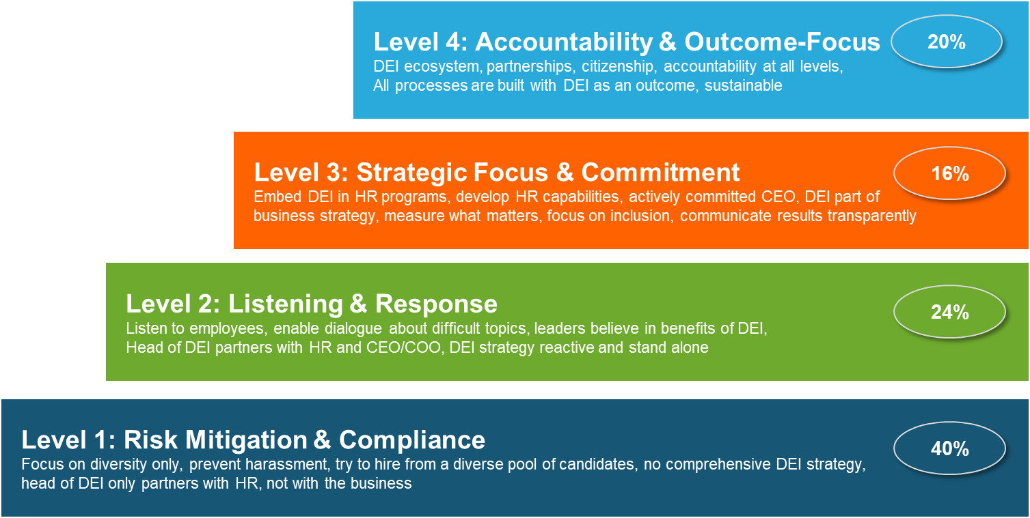
Figure 16: Levels of DEI Maturity
Organizations at Level 1 have the lowest performance in financial, organizational and workforce outcomes, and Level 4 organizations are highest performing. We arrived at these levels based on the more than 800 responses we received to our survey and the practices implemented by their organizations. Industry segment, company size, and geography do not factor into maturity levels Generally, listening to employees is the core response, but more successful companies also take the right actions and hold themselves accountable for DEI outcomes.
- Level 1: Risk Mitigation and Compliance (40% of surveyed organizations): Diversity work is purely defensive to mitigate legal, compliance, or reputational risks. HR has an enforcer role, and the business does not take any ownership of DEI. There is no comprehensive strategy for DEI. Some companies at this level are in risk-averse industry segments; others have leaders who do not understand the power of DEI.
- Level 2: Listening and Response (24% of surveyed organizations): These organizations have leaders who believe in the benefits of DEI to the business. Company leaders listen frequently to employees to identify barriers to DEI, and address those barriers, but mostly in one-off, programmatic ways and without an overarching strategy.
- Level 3: Strategic Focus and Commitment (16% of surveyed organizations): Organizations at this level get direction from the CEO to drive DEI into all aspects of business and people programs. HR people are equipped to address DEI issues. The focus encompasses both diversity and inclusion, with measurements in place to prioritize and set direction. These organizations have built a cohesive DEI strategy and approach unique to their business and people environment and are executing on that strategy effectively.
- Level 4: Accountability and Outcome-Focus (20% of surveyed organizations): Organizations at this level build all processes with DEI as an outcome, create an ecosystem for DEI that encompasses customers, suppliers and partners, and share accountability at all levels. These organizations are running DEI as a business function and take care to ensure sustainability. DEI is not viewed solely as a way to demonstrate good corporate citizenship and to right social wrongs; it is core to the business itself.

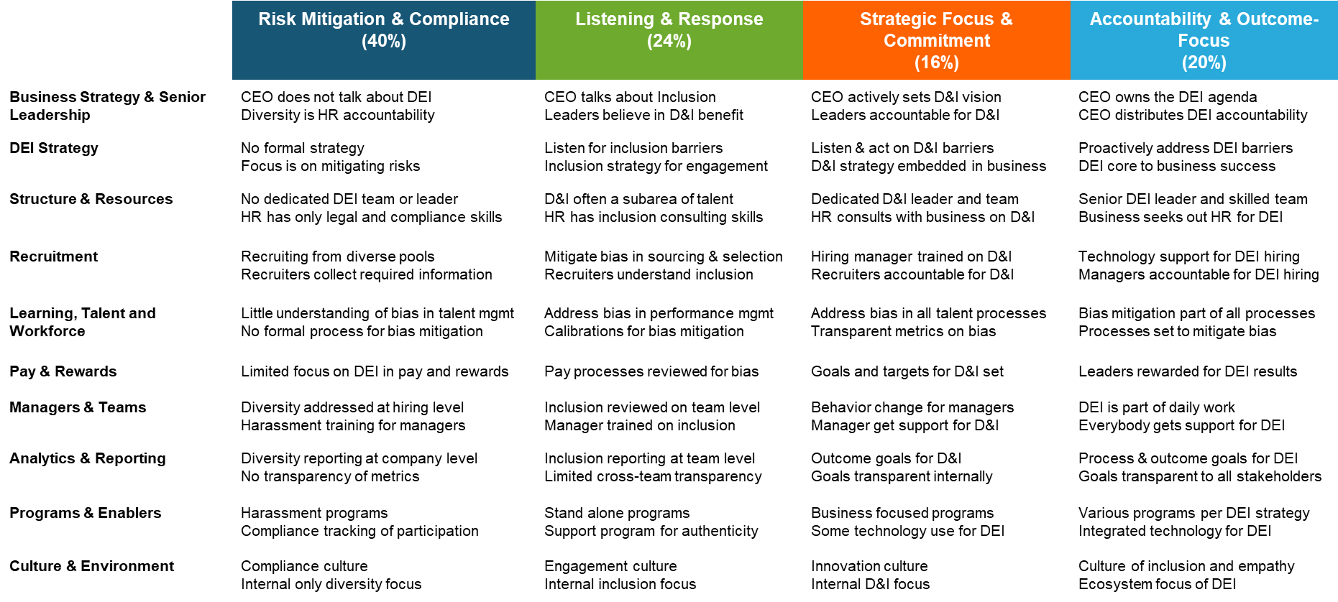
Figure 17: Characteristics of DEI Maturity Levels
Leaders need to take accountability for advancing DEI maturity. Most of the actions to advance maturity are long-term journeys. Without continuous commitment to DEI, it’s easy to backslip. But DEI can no longer be an optional HR program. The impact on customers, financial performance and innovation is significant, and without a dedicated and ongoing focus, DEI outcomes and business performance are just not sustainable.

The Business Impact of the Fifteen Practices
Why should you care about improving maturity in DEI? We established that this is a long, hard journey. The DEI leaders in our working groups tell us the work is exhausting and requires dedication, skills, experience, and passion. Moving from one level to the next takes hard work and often many years.
But our research shows that business, organizational and workforce outcomes all improve as organizations mature (see Figure 18).
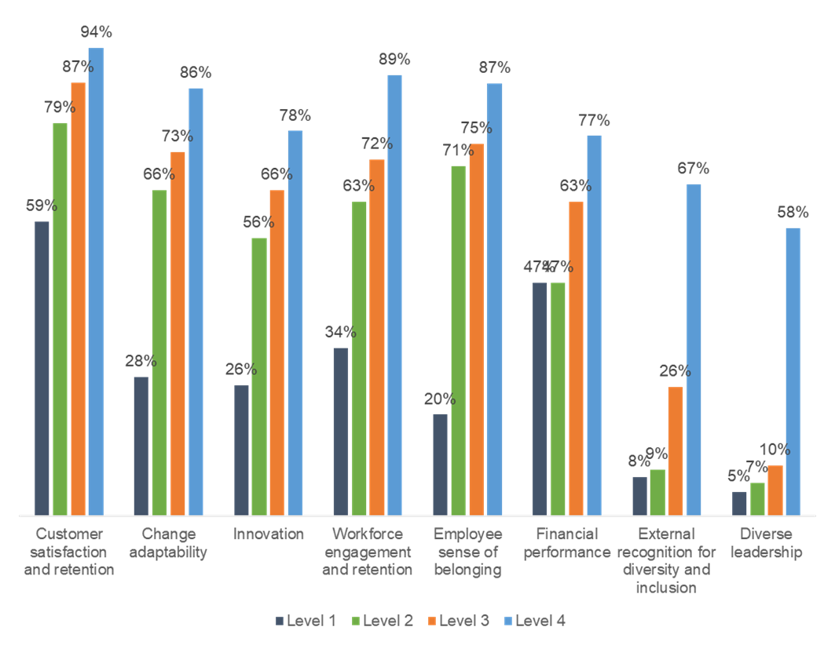
Figure 18: Impact of DEI Maturity on Key Outcomes
Different outcomes increase most significantly at different transitions. Customer satisfaction, change adaptability, innovation, employee engagement and belonging all improve most significantly from Level 1 to Level 2 when companies listen to the workforce. At Level 3, financial performance increases as companies take the right actions. Increased accountability at Level 4 results in much better diversity outcomes.

What Business and HR Leaders Should Do Now
No silver bullet will magically move an organization to a more inclusive state. Best practices from one company may not work for another. But you can’t give up because the stakes are too high, and your employees trust you to make change happen. When we asked survey respondents about the state of DEI in their organization, we got over 1,200 comments. Here are some common themes:

What’s Working Well: Leaders Are Generally Committed
When respondents were asked about what their company does better than others related to DEI, many answers were around leadership commitment. Comments suggested that leaders are truly bought into the value of DEI. This was backed up by the numbers: 65% of respondents indicated that business leaders in their organization believe diversity is good for business.
As we established in our findings, senior leadership commitment is a prerequisite of DEI success, and it is a factor that has bigger impact on outcomes than practices around training or recruitment. This is encouraging for the future of DEI.

“What we do better than most is being truly committed.”
“Only speaking about progress when we hand-on-heart can say that we've made a step forward.” “Taking it perhaps slower or more conservative than some other companies, but really seriously.”
“We don't believe in mandatory training as a check-in-the-box activity, but would rather work in multiple ways to ensure our leadership ‘gets it.’”

What’s Missing: True Accountability at All Levels
Although many leaders are supportive and committed, accountability at all levels is often missing. Several comments mentioned that the support by leaders doesn’t always translate into the right actions – be it funding, sponsorship of initiatives, role modeling or rewarding DEI outcomes. Looking at the numbers, we get the same insight: a mere 12% of organizations reward leaders based on DEI results.
Accountability is the factor that moves companies into the highest-performing level where they excel in business outcomes and performance, diversity and inclusion results and employee engagement. All the right actions without accountability will not allow sustainable progress.
“What’s missing for us is serious accountability at the leadership level to drive the DE&I strategy consistently across geographies and employee levels."

How to Advance in DEI Maturity
You might wonder which maturity level your organization currently is at. You can benchmark your organization’s DEI practices against a big database to check how you compare to peers. But so what? In order to advance, it’s important to understand what the most important actions are to move up in effectiveness and how to build them out in your organization.

Moving from Level 1 to Level 2: Start Listening to Your People
Organizations at Level 1 are just mitigating risks, without capturing any real benefits from DEI. Many studies show that diversity is good for business, but yet just 18% of companies at Level 1 have leaders who believe that. To reap business benefits from diversity, organizations need to start understanding barriers to inclusion by listening to employees, hearing their concerns and taking decisive action.

 | What leaders can do | What HR can do
Define what DEI means for your business and frame a strategy for it | Articulate where DEI fits into your business strategy, focusing on the overall business benefit. Communicate this vision broadly and frequently. Cisco redefined its purpose in early 2020 to “power an inclusive future for all” and bringing inclusion to the forefront of all business processes. | Analyze data about diverse teams in your organization, and connect it to customer and financial data to demonstrate where diverse teams make the biggest impact. Siemens, Kaiser Permanente and others have shown that when teams are more diverse, they have better customer and financial results. Communicate these insights and define how to spread successful practices across teams.
Establish a comprehensive employee listening strategy, focusing on identifying and mitigating barriers to DEI | Conduct frequent employee listening forums with clear rules that encourage people to speak up freely and create a culture of active and respectful listening. J&J has employee listening embedded in its credo that guides all work: “Employees must feel free to make suggestions and complaints.” | Invest in an end-to-end listening strategy that includes active listening (surveys, polls, focus groups, discussion forums etc) and passive channels (sentiment analysis, support ticket analysis, organizational network analysis) that permeates the employee life cycle. Specifically look for barriers to inclusion. Uber, AB In Bev started listening weekly during the pandemic to keep the pulse on employee voice.
Clearly identify how actions will be prioritized, who is accountable, and how actions and results will be communicated to people | Incorporate ideas from the listening session in broad-based communications such as townhalls, in leadership memos, and on corporate portals. Highlight ideas oming from employees. Many organizations stepped up communication frequency during the pandemic and also did more to elicit employee suggestions and two-way dialogue. | Establish prioritization criteria up-front and communicate them to employees. Clarify that all ideas should be raised but not all will be implemented. Then, follow up with action plans and communicate progress along the way.
Showcase examples and stories demostrating how diversity benefited the business and find business champions for DEI | Identify a subject you are passionate about and share with other leaders and on your teams. A senior vice president at Avnet served as a role model on how to incorporate notions of White fragility in work and shared this with other leaders across the company. | Find leaders who are interested in championing concepts that increase inclusion and equity and help them spread the word to other leaders. Facilitate leadership discussion groups to determine where there is energy and then support leaders to walk the talk. TetraPak used local D&I panels with business people to identify champions.
Build the concept of authenticity into management development programs so managers can model it with their teams | Determine where you can model authenticity and vulnerabilityand share stories of where it supported progress. Coach managers on your team to model authenticity at work. At Target, leaders across the organization facilitate listening sessions using guidelines for respect and active listening; these have resulted in many ideas for improving inclusivity in the culture. | Incorporate authenticity into your management development program and review existing development and training for opportunities to embed that notion. Help people model how to present one’s authentic self. A European bank involved employees in developing a new dress code that helped them be their authentic selves and connect better with customers.
When companies start actively listening to their workers, hearing what they say, and then taking action to resolve barriers and mitigate biases, they can accomplish much better results across a number of areas. Customer satisfaction, change agility, innovation, employee engagement and a sense of belonging all significantly improve when organizations move from Level 1 to Level 2. When employees are involved in developing solutions to issues around their work environment, they perform better and provide better service to customers (see Figure 20). Siemens uses design thinking approaches to identify and develop solutions to diversity, equity and inclusion issues and has seen dramatic improvements in employee engagement and customer success as a result.
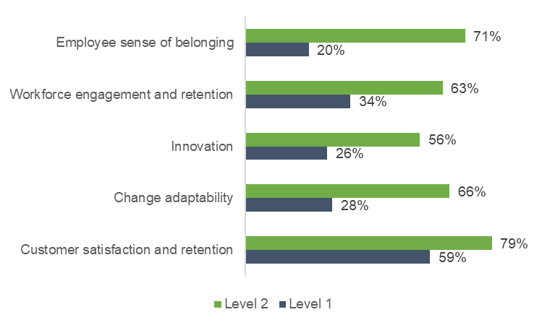
Figure 19: Outcomes That Change Most from Level 1 to Level 2

Moving from Level 2 to Level 3: Embed DEI Everywhere
Organizations at Level 2 are actively working with employees to create a more inclusive environment, and have started a strategy for inclusion and are driving it through HR. However, most actions are programmatic and standalone, rather than embedded into business practices and daily work.
Movng to Level 3 is a significant jump. Organizations need to build HR capabilities, enact active leadership commitment and sponsorship of the DEI strategy and start measuring outcome goals. Embedding DEI into every aspect of the company – the business strategy, every HR program and daily work processes – is not an easy task, but requires constant work and dedicated focus.

 | What leaders can do | What HR can do
Connect the DEI strategy with your business strategy to make it an important part of getting outstanding results for customers | Work across the leadership team to determine which customer, financial and operational goals are best supported by DEI and write a common strategy. Consumer Reports communicates DEI results together with financial and customer results to show that connection. | Facilitate the discussion with business leaders on how DEI contributes to their business goals and help them write specific DEI objectives for their business functions to support the overall DEI strategy. Cisco uses agile HR teams to create business-oriented solutions driving inclusion into the business.
Build deep HR capabilities in DEI that go beyond awareness | Work with your HR business partners on any DEI issues in your organization to create a shared understanding and consultation on these topics. J&J, Herc Rentals, and Prudential see the strategic partnership of HR with the business come to life because leaders trust and rely on consulting for DEI topics. | Invest in an HR development program to raise DEI capabilities for all HR people. Consider outside resources, mentoring, coaching and learning networks. A consumer products company built a custom program that partners DEI experts with HR business partners to allow for knowledge transfer.
Embed DEI in every HR program | Articulate areas of opportunity in existing HR programs (e.g. recruiting, succession, performance management). Form SWAT teams to help identify the points of need n each area. | Appoint a cross-functional SWAT team to review all HR programs and policies with a focus on DEI and make any needed changes. Siemens used a design thinking workshop to identify opportunities, prioritize work and then set up workstreams for the most pressing issues.
Measure the most important areas and communicate progress | Participate in external discussion groups on DEI practices to identify strengths and opportunities. Establish specific goals for your organization and communicate them broadly and frequently. Walmart doubled the frequency of reporting DEI metrics to drive a more inclusive organization. | Establish a dedicated role for DEI measures in the organization, partner externally to benchmark metrics, establish goals and measure progress. Target and Kaiser Permanente have people whose full-time job is just that. Facebook has a D&I analytics team dedicated to driving insights in this area.
When organizations add a business focus to the culture of listening and inclusion, all business outcomes improve, but most significantly financial results. (See Figure 21.) Cisco saw a significant business performance improvement after reframing its purpose statement to focus on creating an inclusive future.
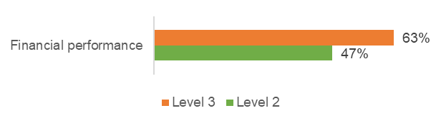
Figure 20: The Outcome That Changes Most from Level 2 to Level 3

Moving from Level 3 to Level 4: Hold Yourself Accountable
Level 3 organizations are bought into the business benefit of diversity, create an inclusive environment through frequent listening to employees, scale DEI through highly skilled HR people, have actively engaged senior leaders who drive DEI into the business, and measure the right outcomes. In order to make DEI sustainable, they must also hold themselves accountable.
Accountability has to occur at all levels of the organization as well as outside of the company. Driving accountability into the ecosystem of vendors, partners and customers helps make an even broader impact on society, communities and all stakeholders.

 | What leaders can do | What HR can do
Think beyond company walls | Review your supply chain and your customer offering for opportunities to increase diversity, equity and inclusion. Hilton sees making every guest feel welcome as key to business success, and one of its DEI pillars is “marketplace.” | Work with customer facing teams, procurement and finance to drive DEI into the ecosystem and build this into the DEI strategy. Ecosystem diversity is at the foundation of Target’s DEI strategy.
Embed DEI in all learning and leadership development programs | Provide your leadership team with actionable, frequent feedback on their DEI capabilities and support them to enhance. Siemens provided a D&I playbook to all people managers describing the why, how and what of D&I. | Audit learning and leadership development programs with a focus on DEI, taking into account the specific problems people face in your organization. A healthcare company has a dedicated role in HR that reviews all new programs with DEI in mind and provides the designer with actionable suggestions for improvement .
Empower the CDO to distribute accountability for DEI results to leaders across the organization and at different levels | Work with the head of diversity to understand accountability for leaders in your organization, discuss how to measure and improve that accountability. Herc Rentals focuses on changing behaviors first, knowing that will be followed with changes in mindset. | Partner with the head of diversity on establishing accountability measures and drive them into different practices (e.g. rewarding leaders based on DEI results, recognizing excellence in DEI). P&G makes 10% of executive compensation dependent on DEI results.
Co-create solutions with employees | Listen to front-line employees to identify issues, allow them time and space to experiment with solutions, and reward and recognize successful practices. Also create space for “smart failures” to create a mindset of continuous learning. | Bring together facilitated design teams from across HR and other parts of the business to experiment, scale and continuously improve. Siemens uses human-centered design approaches for solving DEI issues.
Without accountability built into the fabric of the organization, DEI will always be a futile exercise of starts and stops. But accountability is more than just forcing people to do the right thing. It also requires each person to understand and have the skills and capabilities to do the right thing and to acknowledge accountability. Only when DEI outcomes are no longer optional but part of operational KPIs will leaders truly take that accountability.
When these parameters are in place, the organization doesn’t just meet financial objectives, customer satisfaction goals, or employee engagement targets. It also becomes much more diverse and inclusive. We see that the results that improve most from Level 3 to Level 4 are those associated with diversity (see Figure 22).
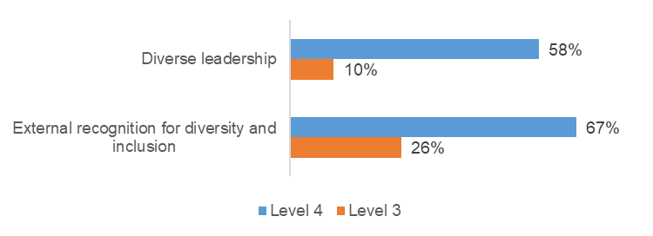
Figure 21: Outcomes That Change Most from Level 3 to Level 4

A Framework For Excellence in DEI
Given the complexity of this topic, we want to give you some clarity. After months of discussion and thousand of hours of research, we put together a detailed and comprehensive framework. As you can see, DEI touches almost everything in the company.
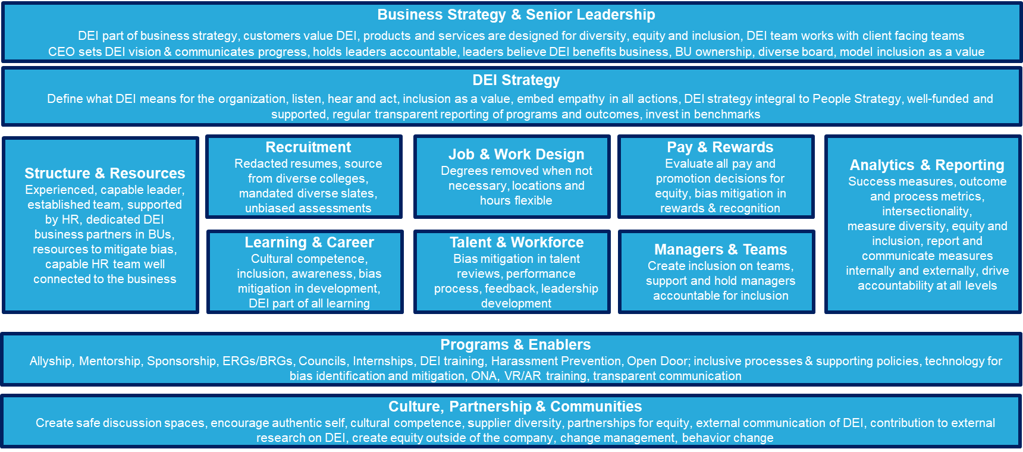
Figure 22: A Framework for DEI Excellence
- Business Strategy and Senior Leadership: The first and most important area is the integration of DEI into the business strategy iteself. In world-class companies, DEI is not a program but a fundamental part of the business. How well does the company mission embrace, mention, and reinforce the concepts of inclusion and diversity?
- DEI Strategy: The DEI strategy is the important groundwork of identifying goals, determining how DEI is defined in your company, and committing to how you communciate DEI within your business.
- Structure and Resources: In this area, the following questions are addressed: How is the DEI function organized and how much money and influence does it have? Is DEI part of HR? Is the head of DEI separate from other functions or embedded in the business? Are DEI leaders embedded in HR or embedded within business units?
- DEI in Recruiting: There are dozens of tools, practices, and approaches to sourcing candidates in a more inclusive and diverse way. These are major investments and critical to maintaining a broad, inclusive, and high-powered candidate pipeline.
- DEI in Career and Learning: In this area, the following questions are addressed: How much training and education do you provide? How is DEI included in career growth? Is DEI considered compliance or part of leadership development? Do senior leaders participate in these programs? Or do you currently have an off-the-shelf solution to create compliance?
- DEI in Job and Work Design: In this area, the following questions are addressed: How do we design jobs, supply chain, and functions so they are inclusive in the business? Do you source offices and locations in diverse cities and communities? Do you search out diversity in supply chain partners?
- Talent and Workforce: How well does the company institutionalize equity, fairness, and data in performance management, succession management, HIPO programs, and all the other things managers do? At Chevron, for example, all talent decisions are reviewed by a diversity committee. It turns out less than 15% of companies do this.Without such oversight, how do we make sure all these decisions are made fairly?
- Pay and Rewards: It’s very easy to look at pay, rewards, bonus, and stock options in any intersectionality quadrant. Pinterest’s COO, for example, found that her options were well behind her male White counterparts, but there was no explanation from leadership. She filed a lawsuit, resulting in a massive brand and leadership challenge for the company. In December 2020, the $22.5M settlement was one of the largest of its kind in history.
- Managers and Teams: How are individual leaders and supervisors trained, coached, and measured on inclusion? Mark Arell from Herc Rentals tells a story about a young manager who complained about “too many girls keep applying for jobs.” (This was deliberate because the company creates diverse candidate slates.) He coached the leader by saying, “That’s just the way we do things around here, and you’ll get used to it.” His philosophy is that teaching people about DEI isn’t the answer; forcing them to get used to it will change their belief systems. I found this to be true at IBM in the 1980s when affirmative action was actively in effect.
- Analytics and Reporting: In DEI, there are hundreds of things to measure. As you read in this report, measuring things and holding people accountable are key success factors. It’s not good enough to publish a DEI report on your website. Yes, that’s a positive step – but when leader know what they’re accountable for and there are consequences for failure, you actually move the needle.
- Programs and Enablers: Here is where we put all the training, tools, events, coaching, and communication programs. While important, our research shows they are all supporting acts to the strategy. When alone, they do not create a diverse and inclusive company.
- Culture, Partnership, and Communities: Finally, one of the most important parts of DEI are the employee resource groups, committees, and external events companies implement. These activities create a sense of community, they let people speak up, and they surface issues that must be addressed. They also give employees a sense that the company cares about equality and inclusion in the cities, towns, and countries where it does business. There are hundreds of ideas here -- from community service to focused programs to discounts and products and services offerings at affordable costs to local customers. Non-profit Management Leadership for Tomorrow )partners with hundreds of leading companies from Abbott, Accenture, Cisco, DaVita, Mars, Nike, Target and Walt Disney to help African American, Latino and Native American fellows bridge the critical college-to-career transition gap to help bring upward mobility for people of color.
We drew the framework from top to bottom because it was easy to visualize in this format. In reality all these elements are important, and this is why we say DEI is a “business function” that warrants its own leader, team, and end-to-end focus. Companies at Level 4 in our maturity model do all these things at scale, and they develop these strategies over years of investment, effort, and continuous improvement.

DEI Is an Ever-Evolving Field
While the diversity topic has been around for decades (going back to affirmative action in the 1970s), the DEI domain is continuously evolving. In the last decade, companies have been focused on issues of disabilities, race, religion, and nationality. Now we are broadening inclusion to encompass gender (and the new definitions of gender), cognitive abilities, age, and virtually every attribute that makes us different. In fact, one of our best DEI leaders defined the domain as “enabling people to bring their natural differences to work and be themselves.”
Workday, for example, recently introduced a new analytics platform designed to measure intersectionality. The word refers to the many ways people can be compared, with many “intersections” working in a matrix. For example, the interview rate for Black vs. White candidates may be on target but the hire and promotion rates may be lower. If you then cut the data by gender you find a huge problem in female Black candidate promotion that may not be visible without looking at that intersection.
Workday told us that it found companies with more than 90 different attributes they want to study – multiple forms of gender, age groups, religion, racial groups, disability, cognitive abilities, and much more. And every year, as another political or social group appears to be disaffected, the DEI teams in companies have to adapt.
What this means is that the DEI “program” or “strategy” must continuously evolve. When we asked survey participants to describe DEI in their organization in one word, the word most often used was “evolving,” followed by “growing,” “infancy,” and “emerging.” (See Figure 4.) The common theme behind these words is that there is a growth trend and that things are at early stages but getting better.
What this means is that highly inclusive companies are always pushing the envelope, learning what new issues are important, and evolving their DEI strategies so their company is always inclusive, fair, and diverse.

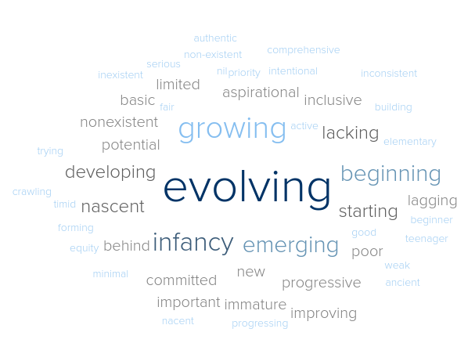
Figure 23: Descriptions of the Current State of DEI from Survey Respondents

Conclusion
Diversity, equity and inclusion is a much discussed topic, but without clear guidelines on how to move the needle. The area is highly complex, and many companies turn to legacy tactics of bias training, diversity recruiting and various programs that sometimes backfire and contribute to more division than unity.
Across industries, geographies and organizational sizes, the most successful organizations are the ones that focus on making systemic change happen. These organizations listen to employees and hear and act accordingly; they have strong, highly capable HR people to consult on DEI and leaders who actively drive change into the organization; and they have set clear, measurable goals that go beyond diversity representation and instill accountability across all levels.
These practices all point to running DEI as a business function, not a set of HR initiatives, with a well-defined strategy that is owned by everybody in the organization and supported by capable experts. This multi-prong approach requires a dedicated focus from top leadership, HR people who know how to drive DEI forward, and a DEI team passionate and knowledgeable enough to do the hard work every day.
Everybody has a role in DEI, from front-line employees to first-level managers, from all areas of HR to the most senior executives. Each of us can make a difference for a more inclusive and equitable world if we show up with new mindsets and skills.

Where We Go Next
If you want to benchmark your organization’s response against the database of over 800 organizations globally to determine where you stand, contact us.
We are also in the fourth sprint of the Big Reset Initiative. We continue discussions around diversity, equity and inclusion with companies around the world.
Finally, let me invite you to join the Josh Bersin Academy, the world’s home for HR. There, you can learn more about the Big Reset work, interact with more than 25,000 of your peers, and find timely resources and cohort-based learning programs, such as the new Elevating Equity program.
If you would like to join the ongoing research program, please email bigreset@bersinacademy.com . We look forward to hearing from you.

Lessons from the Front Line

Tetra Pak Drives DEI Accountability Deeper in the Organization
Tetra Pak is a privately owned multinational food packaging and processing company with Swedish origins and headquarters in Switzerland. The company has over 25,000 employees.
Innovation is at the heart of Tetra Pak’s business. The understanding that diverse perspectives, backgrounds and mindsets are key to innovation comes from the very top of the organization. A comprehensive approach to sustainability, diversity and inclusion is a top priority, along with food safety and environmental sustainability.
In a heavily male-oriented domain, increasing female representation is not an easy task, but the company is committed to continuing its work. Internal studies show that teams with higher inclusion rates are more engaged and have higher retention.
“Protecting our people means driving diversity in our workforce and fostering an inclusive culture, through several actions encompassing training, recruitment and talent development,” said Adolfo Orive, president and CEO of Tetra Pak.
By embedding D&I directly into other sustainability goals, the company demonstrates the impact diversity and inclusion have on business outcomes.
“Listening to our employees is key, and that was the first step we took,” said Gabriele Youd, director of future work for Tetra Pak.
Three years ago, the company created a global D&I panel comprised of 20 people from across the business, at all levels, representing different business groups. The panel was charged with developing a global D&I strategy. Using the annual employee survey and other listening channels, the panel identified barriers to inclusion and drives actions from the insights gained.
For example, the panel pinpointed the need for more flexibility at work, increased access to developmental opportunities, and unconscious bias as challenges to a more inclusive environment. In response, the company changed various policies to give employees the flexibility in work hours and locations and more opportunities for development. Additionally, it trained 1,400 leaders on inclusive leadership principles.
To measure and evaluate progress, the company has a comprehensive D&I dashboard with diversity metrics focused on increasing representation of women in the workplace and an inclusion index derived from the employee survey. The inclusion index is comprised of several questions to measure employee sense of belonging, ability to speak up, support for presenting the authentic self at work and encouragement for growth and development in the organization, regardless of level, gender, race or other demographics.
Through internal and external benchmarking, the company identifies targets, and then these targets and results are communicated to employees and all stakeholders. Over the last year, the trend on women in leadership has been positive, with an increase of 14% of women in senior leadership. The inclusion index, however, is not trending the way the team had hoped for; therefore, new priorities have been identified, based on comments and suggestions from employees.
These priorities include expanding the panel to hear more different voices; a campaign to prevent discrimination, harassment and bullying across the organization, and increased support for onboarding diverse employees.
Senior leadership buy-in to diversity and inclusion has been key to the continued focus and progress. The CEO is actively committed to an orientation towards people, and he holds his leadership team accountable for making progress on D&I.
‘Now, to drive accountability further into the organization, we expanded the global D&I panel to include more diversity and hence different voices, with the same number of people. We also launched four regional panels with 10 members each, so overall we now have 60 people on the panels. The regional panels develop regional action plans and provide oversight of execution of those plans,” said Youd.
Rather than HR mandating goals and plans, regional businesspeople across all levels establish the plans and then get input from HR (including the D&I team). This approach creates much more accountability specific to each region and helps establish more relevant and useful strategies.
‘We are on a journey, but we think we are on the right track to continue progress. As long as we continue to listen, learn and drive execution within the organization, and are governed by a common global framework, we expect to continue progress,” said Youd. “Our D&I panels are key to that journey because they drive accountability into the organization.”

Siemens Uses Design Thinking to Create a More Inclusive Environment
Siemens AG is a German multinational conglomerate company headquartered in Munich. It is the largest industrial manufacturing company in Europe. The company is a prominent maker of medical diagnostics equipment and its medical health-care division, which generates about 12 percent of the company's total sales, is its second-most profitable unit, after the industrial automation division. Siemens and its subsidiaries employ approximately 385,000 people worldwide.
A 173-year-old company operating in many countries and across various industries, Siemens has many programs and initiatives. “If only Siemens knew what Siemens knows – applies to DEI as much as it does to many other topics,” said Anna Mouchref, who leads culture and diversity at Siemens Digital Industries. As Mouchref started her work to lead diversity for the Digital Industries division 18 months ago, she conducted an activity analysis of all DEI-related practices that were currently underway. This resulted in a 60-item list of initiatives that were all well-intended and had significant effort behind them but were ultimately lacking more visible impact.
“What was missing was a global strategy,” explained Mouchref. To create that strategy, she brought together HR, talent acquisition and D&I leaders from across the company in a design thinking workshop. The goal was to identify how to embed DEI within systems, culture, and practices, starting with the employee at the center. The result was a map of four core workstreams with supporting initiatives. The group then prioritized the initiatives and created work teams and project plans for the top three strategic priorities. All work centered on embedding or strengthening DEI practices in existing programs, rather than creating new ones.
In the past, Siemens had a more primary focus on empowering women in the workplace, centered around quotas, hiring aspirations and goals for managers. However, in addition to being limited, the longstanding focus on female empowerment led to a narrow definition of diversity, resulting in unintentional exclusion of other diversity dimensions. So, Mouchref and her team decided to recalibrate the case for D&I, while including women empowerment, and determine how best to move forward.
One key tenant of the new strategy was to strengthen the role of middle managers as culture influencers and role models for employees. To equip this critical segment to amplify the focus on DEI, a global work team used design thinking and human-centered design to develop, test, and iterate a leadership playbook around fostering diverse and inclusive teams. It encompassed three areas:
- The why. What is diversity at Siemens? Why does diversity matter for Siemens, my team and me? In what ways does having a diverse team contribute to our success as an organization? The purpose needs to be really clear, and include organizational, team and individual benefits.
- The how. How do you make it work? Included in this section were practical tips on enacting senior leadership support, diverse hiring practices, small acts of inclusion like being mindful of different time zones, and the best ways to talk about diversity with the team.
- Let’s go. This part walked people through practical exercises, self-reflection tools, and suggested action plans, with templates and resources to apply the learning right away and track progress.
The playbook was endorsed by Global Chief Diversity Officer Natalia Oropeza and sent by the Global Head of HR at Siemens Digital Industries Liliana Gorla to 7,150 people leaders and was very positively received.
Another priority for driving increased diversity into the organization was better use of measurements and defined accountability. The company now has a global D&I dashboard with metrics for hiring, promotion, succession, growth and retention. Its global engagement survey also includes elements on inclusion, diversity and culture.
“The key is to make D&I an embedded part of the daily work life and to make it relevant and engaging for people,” said Mouchref. To that end, the team created a visual leader board called “The Race to Diversity” in an effort to enhance the experience of creating more social awareness of and impacting behaviors to diversification of top-level roles.
“We were doing a lot of good things already. When we make DEI about people and create specific ways to affect change on an individual, systemic and people levels, we can have a much more meaningful impact,” said Mouchref.

Target Manages DEI as a Business Function
Target Corporation is the eighth-largest retailer in the United States and is listed on the S&P 500 Index. Target operates over 1,800 stores throughout the United States, with more than 360,000 employees.
Eighty percent of Americans are within 10 miles of a Target store. This means that the communities Target operates in are as diverse as the United States, and the impact Target can play on creating a more equitable, unified and inclusive environment is massive.
Target has been on a 15-year journey to work on diversity, equity and inclusion and frequently is acknowledged for its work in this area. In fact, in our review of five different “best of diversity and inclusion” lists, Target is on three of the lists – just one of nine companies with such a distinction.
“We run DEI as a business function, not as an HR initiative,” said Kiera Fernandez, chief diversity and inclusion officer and senior vice president of human resources for Target. By this, Fernandez means there is a clear strategy, with established success metrics, senior leadership support, and wide accountability for DEI across the organization.
“You wouldn’t run your finance function without a strategy and clear metrics, and you wouldn’t expect the CFO to own accountability for financial results without these in place. The same has to be true for DEI,” said Fernandez.
To distribute accountability across the organization, each business group has its own DEI strategy, aligned with and driven by the enterprise strategy. From stores to IT, from product management to merchandising, from facilities to HR, each group defines its DEI goals, how they will be executed, and who is accountable for results.
Target’s senior leadership team takes an unapologetic and unambiguous approach to clearly define expectations and what’s right for people at Target, making sure that everybody knows and understands what the company stands for.
Backed by quarterly metrics, the company drives accountability across all levels. The company invests in analysts who are entirely focused on generating insights from the most impactful metrics in DEI. This investment helps continuously hone the strategy and prioritize what’s most needed to drive progress. “One thing we are still finetuning is how to measure inclusion in the right way – to get to the bottom of what an inclusive environment means,” says Fernandez.
Target’s 2021 DEI strategy includes building and enhancing HR skills for DEI, using a curriculum focused on cultural competence and inclusive environment that incorporates formal and informal forms of learning. The content is revisited every year because the space keeps evolving and events change. For example, the team created a six-week program on dealing with crisis related to the recent U.S. presidential election – aimed at HR people. Then, it also provided a scaled-down version to line managers, for the first time ever.
The strategy gets operationalized through an ecosystem approach. In addition to workforce diversity, equity and inclusion, Target also actively focuses on diversity of the supply chain, partners, vendors and customers – all in an effort to build external collaborations for a more inclusive world.
In summer 2020, when George Floyd, a Black man, was murdered by a White police officer less than ten miles from Target’s corporate headquarters in Minneapolis, the company rapidly implemented listening sessions. Employees were invited to open listening sessions, facilitated by business leaders, during which all participants were encouraged to speak up. This is an opportunity to bring the team together to listen, to learn, to share and just be there for each other.
The DEI team organizes the listening sessions and provides guiding principles -- such as being your authentic self and listening courageously -- with business leaders or affinity group leaders facilitating the sessions. While pre-Covid sessions conducted in-person were more intimate, the post-Covid use of virtual Zoom has enabled more people to be part of the sessions regardless of their locations. In these sessions, anyone who want to share gets the opportunity to speak, regardless of title, tenure, or point of view.
Besides serving as a forum for people to be heard, the listening sessions also give great insights to leadership. For example, Target was one of the first companies to make Juneteenth a formal organizational holiday. The CEO sent broad communications to all employees and other stakeholders to strongly condemn institutional racism. Additionally, the team created a training for all people leaders to learn about racism and how to combat it. Called “This Is the Time,” the training is designed not just to educate, but also to establish accountability.
The final and most important issue for Target is how to drive accountability when it comes to DEI. Fernandez describes it as “the million-dollar question.” “You can’t drive accountability if you haven’t done the foundational work. This entails describing to your organization what diversity, equity and inclusion means, how it aligns to your company's purpose and vision, and how it impacts strategic planning, workforce planning, team metrics and business outcomes. This journey takes a long time, and you are never done with it – just like you are never done with refining your business strategy or running your finance function,” said Fernandez.
‘It's a disciplined, time-consuming body of work in which each step builds upon the other. And it can't be built on sand; it has to be built on bedrock. Sometimes it’s two steps forward and three steps back to get it right,” said Fernandez.

Consumer Reports Commits to Diversity, Equity and Inclusion for Everybody
Consumer Reports is an American nonprofit consumer organization dedicated to unbiased product testing, social research, investigative journalism, education and policy work. The organization is headquartered in Yonkers, New York, and has about 600 employees.
Founded in 1936, Consumer Reports has long been a powerful consumer advocate. The rigorous evidence-based work of its employees has resulted in meaningful protections that range from product and food safety laws to improved manufacturing practices, financial fairness rights, and digital privacy standards.
As a social enterprise committed to creating a fair, just, and safe marketplace for all, it is no surprise that its internal DEI strategy is aligned to CRs growth and external impact strategies. CHRO and Chief Diversity Officer Rafael Pérez and his team actively partner with the CEO and other leaders to strengthen Consumer Report’s culture and continually evolve experiences to make all employees feel welcome and supported.
To drive this evolution, a DEI committee of senior leaders and internal partners from across the organization was established to set strategy, develop plans, and oversee execution. After the killing of George Floyd on May 25, 2020, the company sent out a clear message on where the organization stands on racial and social justice, and the committee began work to deliver on the organization’s commitment and employees’ desire to see more and do more — internally and externally.
“We developed seven clear DEI commitments that outline our beliefs and the actions we will take to drive positive change in people’s lived experiences. These commitments cover areas such as talent acquisition, partnerships with other organizations, independent assessments of our research, editorial, and workplace practices, and metrics transparency,” said Pérez.
Then, the team created a DEI accountability tracker to monitor specific tactics and milestones related to each commitment. For example, the tracker defines the data that is openly shared with employees through the actively managed DEI intranet site.
The committee members continue to work and meet on a weekly basis, and progress on each commitment is communicated to all employees on a quarterly basis. “When we published our progress status at the end of 2020, some actions were completed, some were in progress, and some not yet started. We want to be honest in saying what we haven’t done yet; that transparency helps our people trust that we take DEI seriously,” Pérez explained.
“Accountability is important, but you can only create accountability if people understand what they are accountable for and have the skills and tools needed to execute. So you need to educate first, before you can assign accountability,” said Ray Narine, head of talent development and deputy diversity officer at Consumer Reports. Narine and her team have dedicated much time and energy to ensure people understand the DEI strategy and understand what accountability entails.
Another success factor in bringing about meaningful change is explicitly weaving DEI into everything the enterprise does, rather than treating it as a stand-alone initiative. The committee reports data and progress as part of CR’s quarterly enterprise scorecard update to staff as well as to the organization’s board of directors, alongside expense, revenue, and other operational and impact drivers. This small change sends a big message – DEI is a formal part of the enterprise’s strategy, and not just an HR initiative. The committee regularly questions and explores how to further embed DEI into all facets of Consumer Report’s work, and regularly experiments with innovative ways of communicating diversity, equity, and inclusion as top-of-mind priorities for all staff.
Pérez acknowledges the need to play the long game when it comes to DEI. Next, Pérez, Narine, and the rest of the leadership and HR teams at Consumer Reports will reimagine the culture and reset how they actively manage people’s growth to prepare them for the “next normal.” Pérez sees the opportunity for substantial transformation. “Our approach to talent management will need to change significantly. It’s a big part of identifying diverse talent and helping everybody experience and feel their development as part of their work in creating the future of our social enterprise.”

Hilton uses a three-pronged framework for an inclusive environment
Headquartered in McLean, VA, Hilton is a multinational hospitality company that manages a portfolio of 18 brands comprised of more than 6,300 properties in 118 countries and territories. The company employs over 385,000 team members.
For Hilton, diversity, equity and inclusion is a business imperative. Executives are committed to DEI because they know that it’s critical every guest – regardless of background, gender, ethnicity, age or any other characteristic -- feels welcome at Hilton. “We’re very proud to have built an inclusive and award-winning culture that keeps diversity at the center of everything we do,” said Christopher J. Nassetta, president and chief executive officer.
While inclusivity is in the company’s DNA, Hilton’s DEI journey started in earnest more than a decade ago. Initially, the focus was on increasing diversity of the workforce. This approach expanded over time with leaders working to ensure Hilton is a welcoming and inclusive environment for all.
To drive this commitment forward, Hilton uses a three-pillar framework:

- Culture: This area focuses on changing behaviors and embedding DEI into the business to create an inclusive environment. “Our Inclusive and Respectful Workplace curriculum is a foundation. We are also focused on driving progress based on feedback from our team members, through employee surveys and ongoing dialog with our team member resource groups,” said DeShaun Wise Porter, vice president of diversity, inclusion, and recognition.
- Talent: The DEI team works closely across all talent functions to embed DEI in every aspect of the talent life cycle – including candidate attraction, recruitment, learning and career opportunities, performance management, rewards, promotions, succession management, leadership development and employee engagement and retention.
- Marketplace: This pillar is all about creating a more inclusive society and community through external partnerships, such as Hilton Effect Foundation which works to support a variety of non-profits, hurricane relief, scholarship funds; and a focus on supplier diversity.
In May 2020, when social justice movements were triggered by the killing of George Floyd, the team quickly pulled together a “courageous conversations” series to encourage dialogue about that event and related issues with both internal and external speakers. Chris Nassetta and Great Place to Work CEO Michael Bush led the first conversation - a discussion about systemic racism and its impact on people of color across the U.S. The next session focused on privilege and allyship, sharing real examples of how team members can use their own privilege for the good of others. More recently, the series addressed diversity and inclusion in the guest experience. “We wanted to really drive home how each team member has a role to play in ensuring that guests walking through the door feel welcome - regardless of their nationality, race, creed, or sexual orientation,” said Wise Porter.
Team member resource groups are another way the company makes the culture more inclusive. “Through our TMRGs, team members activate around the common principles of networking, professional development and creating educational opportunities that drive allyship. Through meaningful connections, we are able to openly build awareness of challenges other diverse segments may not face,” explained Wise Porter. TMRGs also help inform the company’s marketing and strategy. Instead of only using external focus groups to test out offerings for certain audiences, Hilton also uses the TMRGs to get input on the perspectives of various communities. Each TMRG is sponsored by an executive committee member.
To drive accountability, the executive team has established short- and long-term goals for DEI and cascades them through the organization. “The key is that DEI has to be supported at all levels of leadership. When everyone buys in, the results are more impactful,” said Wise Porter.
Goals and results are transparent and communicated widely. DEI goals are set and reviewed regularly with the company’s board of directors and are tied to leadership compensation, signaling that the company views DEI as a business imperative. “While we continue to be proud of the progress we’ve made as a company to move the needle on issues of DEI, we know this is a lifelong journey. Knowing that deep change takes time, we will be patient but persistent because we believe progress is a must,” said Wise Porter.

Appendix 1: Survey Background: Practices Studied
We studied 84 practices across a broad range of topics and identified ten that mattered most when we correlated them to high performance across seven business, organizational and workforce outcomes.
The full list of practices studied is below. Followimg are the 15 practices that matter most, ordered by their impact on outcomes:
- Frequently listen to employees and act on results.
- HR capability to meaningfully consult with the business on DEI issues.
- CEO articulates DEI vision and communicates progress frequently.
- Communicate DEI metrics internally.
- Focus on DEI in ecosystem (partners, suppliers, customers).
- Embed DEI in every HR program.
- Embed DEI in all learning and leadership development programs.
- Support people to present their authentic selves.
- Set outcome goals for inclusion (eg inclusion index).
- CDO distributes accountability for DEI results.
- Leaders believe diversity is good for business.
- Business partners actively seek out HR to consult on DEI questions.
- CEO holds senior leaders accountable for DEI outcomes.
- DEI strategy is an integral part of our business strategy.
- Invest in benchmarks to measure and drive DEI.
Below are the 69 practices that also matter but have a lower impact on outcomes (grouped by areas):
Senior Leadership
- Our CEO holds senior leaders accountable for D&I outcomes.
- Our board is highly diverse.
- Our organization distributes ownership and accountability of D&I to business units.
Culture and Environment
- Our external website and communications talk about our D&I strategy.
- Our organization measures belonging in our engagement surveys.
- Our organization encourages employees to share their background and cultural experience at work.
- Our organization conducts employee-level forums for dialogue on inclusion topics (e.g., learning circles, coffee chats).
Recruitment
- Our organization actively uses anonymous resumes to help recruit candidates from underrepresented groups.
- Our organization regularly recruits from colleges and universities with representation from diverse groups.
- Our organization mandates diverse candidate slates to drive diversity.
- Our organization uses unbiased pre-hire assessments (e.g., work sample tests, structured assessments/interviews).
- Our organization looks beyond top-tier schools to widen the pool of talent.
- Our organization removes degrees for positions where they are not required to do the job.
- Our organization has diversity committees and/or diversity consultants to review hiring decisions.
- Recruiters are evaluated based on hiring from underrepresented groups.
- Hiring managers are provided with tools and resources to mitigate bias in recruitment.
- Hiring managers are held accountable for recruiting people from underrepresented groups.
Talent and Workforce
- Our organization actively looks for bias in talent review and succession processes.
- Our organization actively looks for bias in performance evaluations.
- Our organization actively looks for bias in rewards and recognition.
- Our organization has programs in mentorship and/or sponsorship to promote diversity and inclusion.
- Our training and information is accessible for anybody (e.g., closed captioning, translation into multiple languages).
Targets, Accountability and Pay
- Senior leaders are rewarded / recognized for diversity and/or inclusion goals.
- We set targets (or quotas) for diversity and/or inclusion which we measure and report.
- We monitor leadership pipeline by gender, ethnicity (looking at each ethnicity separately), age, and other dimensions of diversity.
- We monitor turnover by gender, ethnicity (looking at each ethnicity separately), age, and other dimensions of diversity.
- We monitor engagement by gender, ethnicity (looking at each ethnicity separately), age, and other dimensions of diversity.
- All promotions and pay decisions are evaluated for diversity and equity.
Employee Resource Groups (ERGs)/Business Resource Groups (BRGs)
- Our organization has a wide range of active ERGs/BRGs that meet regularly.
- Senior executives serve as executive sponsors and regularly participate in ERGs/BRGs.
- Our ERGs/BRGs discuss difficult political and social issues in an open way.
- Our ERGs/BRGs are an important part of driving business strategy, and providing products and services.
D&I Training
- We have mandatory diversity and inclusion training for all employees.
- We have mandatory diversity and inclusion training for all managers.
- We have mandatory diversity and inclusion training for our most senior executives.
- We have widely used training on microagression and/or unconscious bias.
- Recruiters go through D&I training at least annually.
- Diversity and inclusion is incorporated in all our learning and leadership development programs.
- We use simulations and/or VR for advanced D&I training.
D&I Structure and Resources
- Our head of D&I reports to the CEO.
- Our organization has had a dedicated D&I team for at least three years.
- Our head of D&I partners closely with our CEO/ COO.
- Our head of D&I partners closely with our CHRO / VP of HR.
- Our head of D&I is highly experienced in D&I issues.
Harassment
- Our organization has a confidential process for harassment or misconduct.
- Our organization has a well defined process for ethics violations or corruption.
- Our organization has a track record of aggressively dealing with harassment issues.
D&I Strategy
- Our D&I strategy is an integral part of our HR/ people strategy.
- Our organization regularly reports on pay equity and publicly shares information.
- Our organization invests in reporting and benchmarks to drive diversity and inclusion.
- Our organization reports our diversity programs publicly.
- Our D&I program is well funded.
- Our organization regularly contributes to external research and/or generates our own research to further D&I progress.
Specific Programs
- Our organization has a "women in leadership" program or strategy.
- Our organization has a "minorities in leadership" program or strategy.
- Our organization has programs for neurodiversity initiatives.
- Our organization has dedicated programs for different religions.
- Our organization has a veterans program or strategy.
- Our organization understands intersectionality and looks at many intersection groups.
- Our organization has a strong focus on disabilities and disability advancement programs.
- Our organization actively supports social justice.
- Our organization actively supports generational diversity.
- Our organization has diversity councils and leaders in each business unit.
- Our organization educates and supports people on presenting their authentic self, purpose, and personal growth.
HR Team
- Our organization works very hard to drive diversity, inclusion, and belonging into every HR program.
- Our CHRO/ VP of HR is a strong sponsor and leader on D&I topics and programs.
- We have dedicated D&I business partners embedded in each business unit.
Technology
- Our organization uses technology to support diversity and inclusive practices in pay and rewards (e.g., monitoring pay equity).
- Our organization uses surveys to understand belonging (e.g., inclusion or belonging index on employee surveys).
- Our organization uses ONA to study diversity and inclusion (org network analysis).
- Our organization monitors AI technology for embedded/ algorithmic bias.
- Metrics and measurement
- Our organization sets outcome goals for diversity (e.g., women or underrepresented groups in leadership).
- Our organization publicly communicates diversity and/or inclusion metrics to stakeholders (e.g., shareholders, the board, the public).

Appendix 2: Study Methodology
We conducted the broad-based, global industry study in five major steps:
- Big Reset discussions: Over six months, we discussed with DEI executives in 100+ organizations what DEI practices they deployed and where they saw the biggest organizational challenges, successes and mistakes. These discussions, conducted in different working groups and sprints, helped inform the questions and topics to study in the survey.
- Survey: Taking the Big Reset discussions as input, we created a survey with our research partner Perceptyx, validated it with various DEI leaders from large companies, and launched it into the market in October and November. We received responses from more than 800 people across all industries, geographies and company sizes.
- Analysis: As we analyzed responses, we did descriptive analysis, comparing favorability across various topics and practices and by different demographics to determine perception of DEI practices, as described in Appendix 1. We also did linear regression of the 84 practices against the business and workforce outcomes to determine the 15 practices that matter most. Then, we performed cluster analysis to see how the 15 practices group together, to determine the five success factors. And we clustered organizations into four groups based on their performance in the 15 practices to determine the four maturity levels. Thus, for every respondent who participated in the study, we know the maturity level of the organization. To determine the likelihood of outcomes (e.g.. high-performing / excellent organizations are x times more likely to meet or exceed financial targets compared to low-performing organizations), we identified what percentage of high-performing/ excellent organizations actually accomplished a specific outcome (top two box responses) and divided that result by the percentage of low-performing organizations that accomplished a specific outcome (top two box responses). Similarly, to determine the likelihood of a specific practice in a specific outcome (e.g., companies that listen to the workforce and act on results are x times more likely to meet or exceed financial targets), we identified the percentage of organizations that deployed a specific practice and accomplished a specific outcome (top two box responses) and divided the result by the percentage of those that didn’t deploy that practice and accomplished a specific outcome (top two box responses).
- Interviews: We conducted a number of validation and case study interviews to ensure the practices we identified through statistical research resonated with leaders and practitioners and to elicit case studies and examples. We also presented draft study findings to the Big Reset working group participants and solicited input from more than DEI executives.
- Report preparation: Based on all the input gathered, we prepared this report. The report was also reviewed by several DEI leaders.

https://www.cdc.gov/coronavirus/2019-ncov/covid-data/investigations-discovery/hospitalization-death-by-race-ethnicity.html
https://abc7news.com/women-in-the-workplace-business-pandemic-affecting-coronavirus/8848477/
https://interactive.aljazeera.com/aje/2020/know-their-names/index.html
https://apnews.com/article/hate-crimes-rise-FBI-data-ebbcadca8458aba96575da905650120d
https://www.mckinsey.com/featured-insights/diversity-and-inclusion/diversity-wins-how-inclusion-matters
https://joshbersin.com/2020/07/chief-diversity-officer-the-toughest-job-in-business/
https://www.amazon.com/dp/B07TFB4CTQ/ref=dp-kindle-redirect?_encoding=UTF8&btkr=1
https://worldpopulationreview.com/country-rankings/gini-coefficient-by-country
https://www.morningstar.com/articles/1003066/can-baby-bonds-shrink-the-racial-wealth-gap
https://www.wsj.com/articles/coke-resets-goal-of-boosting-black-employees-after-20-year-effort-loses-ground-11608139999
https://joshbersin.com/big-reset-2020/
https://abc7news.com/coronavirus-by-race-deaths-and-latino-community/9159622/
https://www.cdc.gov/coronavirus/2019-ncov/covid-data/investigations-discovery/hospitalization-death-by-race-ethnicity.html
https://www.mckinsey.com/featured-insights/diversity-and-inclusion/diverse-employees-are-struggling-the-most-during-covid-19-heres-how-companies-can-respond?cid=other-eml-alt-mip-mck&hdpid=c1bbe9f8-d776-4a09-8941-47284c45c845&hctky=9928658&hlkid=43700042b874441f9f1a168a8dc6e918
https://www.axios.com/corporate-america-black-employee-turnover-rate-91563b14-c87b-435b-b157-0443c586735d.html
https://www.cnbc.com/2020/06/12/six-years-into-diversity-reports-big-tech-has-made-little-progress.html
The Fearless Organization: Creating Psychological Safety in the Workplace for Learning, Innovation, and Growth, Amy Edmondson
Proprietary research based on 2,500 pieces of feedback, Zugata (now a part of CultureAmp)
https://www2.deloitte.com/content/dam/Deloitte/au/Documents/human-capital/deloitte-au-hc-diversity-inclusion-soup-0513.pdf

